## 

**Final Year Project Report**

**QuizLobby**



**Project Advisor:**

**Asad Raza Usmani**

**Submitted By:**

**Sail e Madni (F2016266268)**

**Shizay Tauqir (F2016266189)**

**Amanullah Awan (F2016266207)**

**Session 2016-2020**

**University of Management and Technology**

**C-II Johar Town Lahore Pakistan**

**Dedication**

We would like to give credit and express our gratitude to our families who have supported us throughout our journey, and been there with us no matter what. We would also like to thank Sir Asad Raza Usmani, our supervisor, for helping us bring this project into life and for being available whenever we needed him. Most importantly, we would also like to mention our teachers who have played an important role in increasing our knowledge throughout our degree.

Furthermore, we would dedicate this project to ourselves and to our future as it is the first step towards our career and professional life. However, we wouldn't have made it this far and be able to complete this project without the will of Allah.

**Final Approval**

**Panel of Examiners**

* **Head of Department**  ______________________

Department of Computer Science

UMT Lahore

* **Program Director (Final Year Projects)** ______________________

Department of Computer Science

UMT Lahore

* **Supervisor** ______________________

Department of Computer Science

UMT Lahore

* **Co-Supervisor** ______________________

**Acknowledgment**

We would like to thank our advisor, Sir Asad Raza Usmani, for helping us and guiding us throughout our Project. He’s been a major source of guidance for us. Other than that, we would like to thank our seniors for supporting us. Moreover, our parents play an important role in our success and journey throughout the Univeristy and this Project.

**Project Title QuizLobby**

**Objective Web platform for conducting online quizzes**

**Undertaken by Sail e Madni**

**Shizay Tauqir**

**Amanullah Awan**

**Supervised by Asad Raza Usmani**

**Starting Date**

**Completion Date**

**Tools Used HTML5, CSS3, Bootstrap4, JavaScript, Adobe Photoshop, Python, Djang0, Creately**

**Operating System Windows-10**

**Documentation**

**Plagiarism Report**

**Declaration Form**

I have carefully examined the documentation of the Final Year Project titled *“QuizLobby”*; and I endorse that this documentation complies with the standards of an undergraduate level Final Year Project report.

The document has been checked for plagiarism through Turnitin software available in UMT Library. The similarities of the document are within acceptable range.

Moreover, the accompanying CDs contain PDF of the documentation, as well as the source code and binaries with user manual and installation guide.

**FYP Advisor Name: ______________________________**

Signature: __________________ Date:___________________

**Abstract**

As we all know, Online Classes and Work from Home has become the new normal due to the Covid-19. The educational institutes and many organizations have been closed or partially closed and it has affected the students, teachers, and the hiring staff. The teachers are not able to assess their students accurately, the students are not able to conduct quizzes and exams properly, and the hiring staff is not able to conduct interviews for their organizations properly. Therefore, we have designed a system which will conduct quizzes and exams for every purpose and age group. With the help of this system, the students will not lag behind in their studies, the teachers won't have to manually check the quizzes, and people can get hired for companies on the basis of their scores. Furthermore, our objective includes saving the trees as less or no paper will be used for this purpose.

Revision Chart

|  |  |  |  |
| --- | --- | --- | --- |
| **Version** | **Primary Author(s)** | **Description of Version** | **Date Completed** |
| *Draft* | Sail E Madni | Initial draft created for distribution and review comments | 31/07/2020 |
| *Preliminary* | Shizay Tauqir | Second draft incorporating initial review comments, distributed for final review | 15/09/2020 |
| *Final* | TBD | First complete draft, which is placed under change control | 20/02/2021 |
| *Revision 1* | TBD | Revised draft, revised according to the change control process and maintained under change control | TBD |
| *Revision 2* | TBD | Revised draft, revised according to the change control process and maintained under change control | TBD |
| *Etc.* | TBD | TBD | TBD |

# Contents

Contents9

**Definitions and Acronyms** **11**

**List of Figures** **12**

**List of Tables** **14**

1. Introduction16
2. Motivations 16
3. Project Overview 16
4. Problem Statement 17
5. Objectives 18
6. Domain Analysis19
7. Customers 19
8. Stakeholders 19
9. Affected Groups with Social or Economic Impact 20
10. Dependencies/ External Systems 20
11. Reference Documents 21
12. Requirements analysis23
13. Requirements 23
14. List of Actors 26
15. List of Use Cases 26
16. System Use Case Diagram 27
17. Extended Use Cases 29
18. User Interfaces(mock screens) 48
19. **DATA FLOW DIAGRAM** 62
    1. Data Flow Diagram Level 0 62
    2. Data Flow Diagram Level 1 63
20. **SYSTEM DIAGRAM** 64
21. System Architecture Diagram 64
22. Class Diagram 65
23. Sequence Diagrams 66
24. Login 66
25. Signup 67
26. Create Quiz 68
27. Attempt Quiz 69
28. Other UMLs 70
29. Activity Diagram 70
30. ERD 71
31. **Implementation Details** **72**
32. Development Setup 72
33. Deployment Setup 72
34. Algorithms 72
35. Constraints 74
36. Assumptions 75
37. System Constraints 75
38. Restrictions 75
39. LimitaTionS 75
40. **Testing 76**
41. Extended test cases 76
42. Decision Table 89
43. Code Snippet 89
44. Decision Coverage Table 91
45. Traceability matrix 94
46. RID vs UCID (Requirements vs Use Cases) 94
47. **Results/Output/Statistics 95**
    1. %completion 96
    2. %Accuracy 96
    3. %Correctness 96
48. **Conclusion** **97**
49. **Future Work** **98**
50. **Bibliography** **99**
51. Books 99
52. Articles 99
53. Research papers 99
54. **Appendix** 100
55. Glossary of Terms 100
56. Pre-Requisites 100

## Definitions and Acronyms

Table 1 table of acronyms and definitions

|  |  |
| --- | --- |
| **Acronym** | **Definition** |
| UMT | University of Management and Technology |

## 

## List of Figures

Figure 1: Use case 1 27

[Figure 2: Use Case 2 28](https://docs.google.com/document/d/1EWDBw0HZPsB5u3R96Qrw6oxNvf6cvvxDR4EqPq9YqH0/edit#heading=h.1ci93xb)

Figure 3: Prototype Index 48

Figure 4: Prototype Lower Section of Index 49

Figure 5: Prototype Signup 50

Figure 6: Prototype Signin 51

Figure 7: Prototype Password Recovery 52

Figure 8: Prototype Contact us 53

Figure 9: Prototype About us 54

Figure 10: Prototype Teacher Dashboard 55

Figure 11: Prototype Student Dashboard 56

Figure 12: Prototype Profile Section 57

Figure 13: Prototype Edit Quiz  58

Figure 14: Prototype Attempt Quiz 59

Figure 15: Prototype Timer 60

Figure 16: Prototype Student List 60

Figure 17: Prototype Mail Section 61

Figure 18: Prototype Notes Section 61

Figure 19: DFD Level 0 62

Figure 20: DFD Level 1 63

Figure 21: System Architecture Diagram 64

Figure 22: Class Diagram 65

Figure 23: Login 66

Figure 24: Signup 67

Figure 25: Create Quiz 68

Figure 26: Attempt Quiz 69

Figure 27: Activity Diagram 70

Figure 28: ER Diagram 71

Figure 29: Signup-Algorithms 72

Figure 30: Signup-Front end 73

Figure 31: Login-Algorithms 73

Figure 32: Login-Front end 74

Figure 33: Application Form 74

Figure 34: Code - Create Quiz 89

Figure 35: Code - Save Created Quiz 89

Figure 36: Code - Quiz List 90

Figure 37: Code - Attempt Quiz 91

Figure 38: Code - Save Attempt Quiz 91

Figure 39: Code - Login 91

Figure 40: Code Student Result 91

## 

## List of Tables

Table 1: Table of acronyms and definitions 11

Table 2: List of stakeholders 20

Table 3: Features Comparison 22

Table 4: Functional Requirements 24

Table 5: Non-Functional Requirements 25

Table 6: Signup 30

Table 7: Login 32

Table 8: Create Quiz 34

Table 9: Add Question 34

Table 10: Edit Question 37

Table 11: Delete Question 37

Table 12: Select Question Type 39

Table 13: Edit Quiz  41

Table 14: Delete Quiz 42

Table 15: Attempt Quiz 44

Table 16: Add Answer 44

Table 17: Edit Answer 46

Table 18: Test Case - User Sign up 76

Table 19: Test Case - Login 77

Table 20: Test Case - Teacher Application Form 78

Table 21: Test Case - Add Question 79

Table 22: Test Case - Create Quiz 80

Table 23: Test Case - Edit Quiz 82

Table 24: Test Case - Delete Quiz 84

Table 25: Test Case - Select Course 85

Table 26: Test Case - Attempt Quiz 86

Table 27: Test Case - View Progress 87

Table 28: Test Case - Contact US 88

Table 29: Decision Table - Login 92

Table 30: Decision Table - Attempt Quiz 93

Table 31: RID vs UCID 94

Table 32: RID vs PID 95

# Introduction

## Motivations

With the advancement of time, we are entering a digital era. However, there are still schools and universities in most parts of the world who not only conduct exams on papers but also check them manually. Our primary motivation behind this project is to improve the examination system by digitizing it; it will facilitate both, the teachers and the students. Due to the current situation of Covid’19, all the institutes have been locked down. As a result, the teachers are not able to conduct quizzes or exams and the students are lagging behind in aspects of studies and achieving knowledge. By implementing this online, the studies can continue without any hassle, and it can make the teachers’ lives easier. Another cause of our motivation is that by digitizing the quiz system, papers will not be used. Thus, leading towards the saving of trees. Moreover, the basic motivation for us to carry out QuizLobby is to complete the fundamental requirement of our degree and to implement everything we have learnt throughout. Our aim is to fill this blank space in our educational system and launch it in the market as a product after our graduation.

## Project Overview

With the advancement of a digital era, our educational system has also taken a step forward; the schools and universities are now conducting online classes, especially since the Covid’19 has started. However, our teachers, in most parts of the world, are still doing their work manually, leading to a hectic routine. They don't have automated platforms to conduct quizzes professionally. This is where our QuizLobby project will come in handy, to propose a solution and provide a platform to our teachers.

The QuizLobby community will help Teachers by giving them a web platform where they can easily create a quiz according to their requirements and conduct it online. This will help teachers abstain from manual checking as our quiz checker will display the results. Moreover, this platform will help every educational institute and firms in our country that require an entry test for admission or an interview. The students will also benefit from QuizLobby. The quizzes solved by them and their results will be saved online. They can access it whenever they wish to.

QuizLobby will be used by teachers to create quizzes online for their class, and by the students to answer the quizzes online. It will automatically check the answers which will be provided by the teachers during the quiz creating process. The system will create the result for every student so the teachers can know where every student stands. Some of the features of QuizLobby are mentioned below;

* Create a quiz in the form of MCQs and Q&As
* In Q&As, the sequence of the questions will be shuffled by system automatically
* Teachers will enter the correct answers while making the quiz so it can be checked automatically.
* The Databank will save the questions created by the teacher. This option will be shared with teachers only and it will help them create the quiz.

## Problem Statement

The main problem faced by teachers and students these days (i.e. during the lockdown due to Covid-19) is that they’re not able to conduct quizzes or exams properly without a proper platform. This way, the teachers cannot assess their students and the students cannot analyze where they stand. A huge gap is being created between the teachers and the students which is causing lack of understanding among the students. Moreover, the education system will deteriorate with time instead of improving.

Another problem that our teachers face is creating a quiz and printing them for the whole class. Also, checking a pile of quizzes one by one is a huge hassle. Our platform will share the burden of the teachers and make their life easier as they can create the quizzes online, and the quizzes will automatically get checked. No more papers to pile up in their offices or to carry them home.

Last but not the least, one of the issues that our education system faces are plagiarism or cheating in quizzes. There are many ways the institutes around the world carry out in order to overcome this issue, and no doubt they are very helpful. We intend to take care of this matter as much as we can so our students can work on their own rather than relying on others or the internet. Keeping these issues in mind, we decided to carry out this project and try to make a positive difference in our education system, especially during the Covid-19.

## Objectives

The primary objective of the project is to have a single platform that offers benefits to our teachers and students simultaneously. We would like to contribute in helping the education system get better and stay managed as it evolves its way through the digital era during Covid-19. Our focus is mainly to provide the teachers with functionalities that help them make and check quizzes online, creating ease for them. On the other hand, we have focused on providing students with additional features through which they can improve themselves.

# 2. Domain Analysis

## **2.1 Customers**

Anyone who needs to conduct quizzes online, and needs to check their merit or grades.

## **2.2 Stakeholders**

|  |  |
| --- | --- |
| **Stakeholder** | **Role in System** |
| Designer | Responsible for designing mock screens and intuitive interference of the system for the users. |
| Database Administrator | Responsible for designing the core functionalities, relationships and working of the database of the system. Also focuses on managing the database. |
| Database Designer | Responsible for creating the schema of the database on the theoretical level and implementing new techniques to make the database more secure, efficient and/or responsive |
| Back-End Developer | Responsible for the major portion of the coding that is working behind the system |
| Front-End Developer | Responsible for mapping the design illustrated by the designer via code |
| Quality Assurance and Testing | Responsible for testing the prototypes and reviewing the system as to whether or not it is functioning the way it is supposed to. They are responsible for handling the initial feedback and catering according to the response. |
| Teacher | Responsible for creating the questions, and saving the correct answers for the system to check automatically. |
| Sponsor | Responsible for providing the necessary funds to develop the platform and to keep it functional. |
| Student | Will be the user of the platform |

Table 2: list of stakeholders

## **2.3. Affected Groups with Social or Economic Impact**

* Educational Institutes
* Autodidactes
* HR Departments
* Freelancers
* Companies sponsoring this platform

**2.4 Dependencies/ External Systems**

* Laptop
* Internet
* Servers
* Android Devices

**2.5 Reference Documents**

### **Related Projects**

1. **ClassMarker:**

A website designed for online testing that provides its users to create and conduct online quizzes and keep a track of students’ grades.

1. **EasyTestMaker:**

An online test generator website which is used to create, manage, and conduct quizzes online.

### **Feature Comparison**

|  |  |  |  |  |  |
| --- | --- | --- | --- | --- | --- |
| **Sr No.** | **Comparison Feature** | **QuizLobby** | **ClassMarker** | **EasyTestMaker** | **Remarks** |
| **1** | Auto Checking | YES | YES | YES | The system automatically checks the answers of the questions. |
| **2** | Different Types of Questions | YES | YES | YES | The Quiz Maker has the option to select different types of questions which include MCQs, Long answers, True and False, and can add Pictures. |
| **3** | QuestionBank | YES | YES | NO | The Quiz Maker can add the questions in the Question Bank for later use. |
| **4** | Randomize Questions | YES | YES | NO | The questions will be randomized for each student to prevent cheating/plagiarism. |
| **5** | Access to Result | YES | YES | YES | The Quiz Maker and the Student can access their reports and check their ranking. |
| **6** | Forum | NO | NO | NO | The Students can ask questions on the forum and the Quiz Maker can answer the questions. |

Table 3: Feature Comparison

# Requirements analysis

## **3.1 Requirements**

## **Project Management:**

To handle the development and documentation of this team project, we have to manage all of our duties and the tasks properly. Development has many phases and for correlation of all group members, we made use of some tools that are used for sharing and managing this project.

**Teams:**

This project is based on teamwork; and in teamwork it is necessary to plan each and every step thoroughly. It is important to assign work to each member according to their capabilities and interests. This way the result will be more productive. Managing the team is also part of the requirements. In between the working of the project, we can swipe any task assigned to a member to another, depending on the benefit of the project.

**Tasks:**

* A work breakdown structure will be created.
* Tasks are distributed among team members.
* Description of the tasks are specified
* Tasks will be modified if needed be
* Deadlines of tasks will be appointed

**Google Docs Sharing:**

Google Docs is the most frequent sharing system which will be used to share documents. All team members can edit their part of the work on the document.

**Direct Message:**

Our primary source of direct messaging was WhatsApp. We created a WhatsApp group of all the team members to discuss the details of the project. We were also in contact with our advisor through WhatsApp.

**Voice Calls:**

To help in a better flow of information exchange, we made use of WhatsApp one-to-one call feature. When necessary, we used WhatsApp for group calls as well.

**Video Calls:**

We used Zoom to carry out video meetings when necessary. Zoom was mainly used when we needed to share our screens with the team members.

**Functional Requirements:**

|  |  |
| --- | --- |
| **Functional Requirements** | * Sign up as a teacher or a student and Login * Teachers will create the quiz * Teachers will have the option to set the marks and the type of each question themselves * Teachers can save questions in the Databank for later use * Teachers will have to enter the correct answer as well * A result will be created for students to keep a record of their marks * Teachers and Students can see the result of students |

Table 4: Functional Requirements

**Non-Functional Requirements:**

|  |  |
| --- | --- |
| **Non-Functional Requirements** | * Easy to use interface for kindergarten to PhD level students. |

Table 5: Non-Functional Requirements

## **3.2 List of Actors**

* Teacher
* Student

## **3.3 List of Use Cases**

* Sign-up: User (Student) will be able to create an account using his/her organizational (optional) email address.
* Login: User will be able to login by using email address and password.
* Teacher Application Form: Teacher will have to fill the form to signup.
* Create Quiz: Teacher will be able to create a quiz.
* Edit Quiz: Teacher will be able to edit quiz.
* Delete Quiz: Teacher will be able to delete quiz.
* View Quiz: Teacher will be able to view quiz by downloading a pfd.
* Add Questions: Teacher will be able to add questions to the database/while creating quiz.
* Edit Question: Teacher will be able to edit question.
* Delete Question: Teacher will be able to delete question.
* View Question: Teacher will be able to view question.
* Add Answer: Student will be able to add the correct answer for the questions.
* Edit Answer: Student will be able to edit answers.
* Select Question Type: User will be able to select questions type.
* Create Time Limit: Teacher will be able to select the time limit for the quiz.
* Assign Points: Teacher will be able to select each points for each question.
* Select Order: Teacher will be able to select the order of the quiz questions.
* Access Result: User will be able to see the quiz result.
* Attempt Quiz: Student will be able to attempt the quiz via invitation link.
* Select Option: Student will be able to select options for mcqs type questions.

## **3.4 System use case diagram**

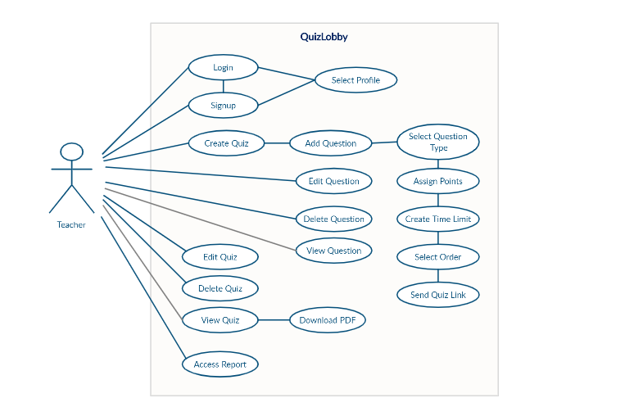

Figure-1: Shows the operations that the Teacher can perform.

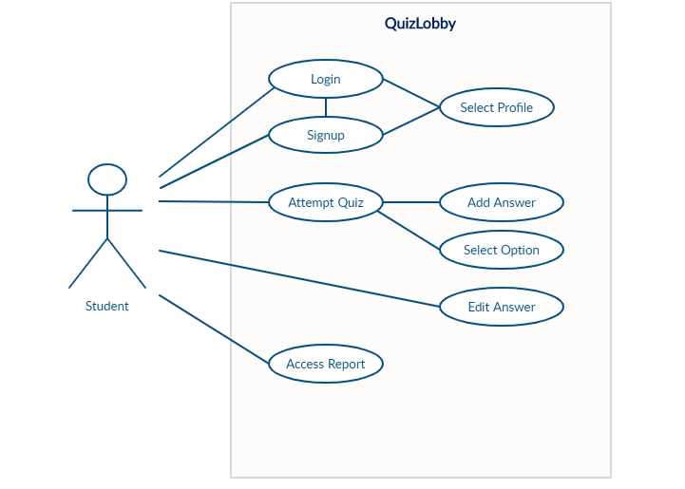

Figure- 2: Shows the operations that the Student can perform.

## **3.5 Extended use cases**

|  |  |
| --- | --- |
| Use Case ID: | UC-1 |
| Use Case Name: | Signup |
| Actors: | User |
| Description: | The account setup procedure that will allow user to avail the services we are providing |
| Trigger: | User clicks the signup button |
| Preconditions: | 1- Internet Access  2- User visits our website  3- User intends to make an account on our website |
| Post conditions: | 1- The account of user created in database with his/her credentials  2- The user account is ready to avail our services |
| Normal Flow: | 1- User visits our website  2- User clicks on the signup button  3- System provides user signup form  4- System prompts user for Username, Password, Email  5- User enters the required credentials  6- System stores the credentials of the user in the database  7- System prompts user to select the profile type Teacher/Student  8- System sends the confirmation email to user’s provided email  9- User account is now functional/active |
| Alternative Flows: | 4.1. In step 4 of normal if username provided by user is available  1. System assigns the user with said username  2. Flow resumes from step 5  4.2. In step 4 of normal flow if username provided by user is not available  1. System prompts user for a different username  2. User enters different username  3. Repeat step 4.2 if the new username is not available  4. System assigns the user with said username  5. Flow resumes from step 5 |
| Exceptions: | 5.1 In step 5 of normal flow if user enters invalid email  1. Signup procedure will not proceed  2. System will prompt user to enter email again |
| Includes: | None |
| Assumptions: | 1- User have Internet Access  2- User is on our website  3- User knows English language  4- User wants to create an account |
| Notes and Issues: | None |

Table 6: Signup

Given above table is signup procedure, this table will help user create account on our website.

|  |  |
| --- | --- |
| Use Case ID: | UC-2 |
| Use Case Name: | Login |
| Actors: | User |
| Description: | The login procedure which will allow user to login in his/her account |
| Trigger: | User clicks the login button |
| Preconditions: | 1- Internet Access  2- User visits our website  3- User provides the correct credentials for login |
| Post conditions: | The account of user is logged in and system displays the homepage to user |
| Normal Flow: | 1. User visits our website  2. User clicks on the login button  3. System provides user to enter username, password  4. User enters the credentials  5. System verifies the username, password from the database  6. User able to logged in into his/her account |
| Alternative Flows: | 4.1. In step 4 of normal flow if user enters wrong username  1. System will prompt user for username again  2. Flow resumes from step 5    4.2. In step 4 of normal flow if user enters wrong password  1. System will prompt user for password again  2. Flow resumes from step 5 |
| Exceptions: | 5.1 In step 5 of normal flow if system doesn’t verify user provided credentials from database and user entered wrong credentials multiple times  1. System will prompt user click on forgot password or username option  2. System will prompt user to enter registered email  3. System will send code to user’s email  4. User will enter the code received from the email  5. User will enter the new credentials for the account |
| Includes: | None |
| Assumptions: | 4- User have Internet Access  5- User is on our website  6- User knows English language  7- User wants to login |
| Notes and Issues: | None |

Table 7: Login

Given above table is a login procedure, this table will help user login into account on our website.

|  |  |
| --- | --- |
| Use Case ID: | UC-3 |
| Use Case Name: | Create Quiz |
| Actors: | Teacher |
| Description: | The procedure of creating the quiz |
| Trigger: | Teacher clicks on Create Quiz button |
| Preconditions: | 1. Internet Access  2. Teacher able to logged in into his/her account |
| Post conditions: | The Teacher will be able to create quiz |
| Normal Flow: | 1. Teacher logged in into his/her account  2. Teacher clicks on create quiz button  3. Teacher clicks on add questions buttons  4. Teacher selects question type  5. Teacher add questions  6. Teacher assign points for each question  7. Teacher selects the order of the questions  8. Teacher will select the time limit of the quiz  9. Teacher will select the view questions button to view questions  10. Teacher will select the view quiz button to download pdf of a quiz  11. Teacher will save the quiz and send the quiz invitation link to students via email  12. Teacher will click on Access Report to see the quiz results |
| Alternative Flows: | None |
| Exceptions: | Teacher unable to log in due to wrong credentials  Teacher unable to create quiz due to poor internet |
| Includes: | None |
| Assumptions: | 1. Teacher have Internet Access  2. Teacher is on our website  3. Teacher knows English language  4. Teacher account is registered at our website |
| Notes and Issues: | None |

Table 8: Create Quiz

Given above table is a creating quiz procedure, the above table will help Teacher to create quiz

Table 9: Add Question

|  |  |
| --- | --- |
| Use Case ID: | UC-4 |
| Use Case Name: | Add Question |
| Actors: | Teacher |
| Description: | The procedure of adding questions to the quiz |
| Trigger: | Teacher clicks on Add Question button |
| Preconditions: | 1. Internet Access  2. Teacher able to logged in into his/her account |
| Post conditions: | The Teacher will be able to add questions to the quiz |
| Normal Flow: | 1. Teacher logged in into his/her account  2. Teacher clicks on create quiz button  3. Teacher clicks on add question buttons  4. Question will be added |
| Alternative Flows: | None |
| Exceptions: | Teacher unable to log in due to wrong credentials  Teacher unable to create quiz due to poor internet |
| Includes: | None |
| Assumptions: | 1. Teacher have Internet Access  2. Teacher is on our website  3. Teacher knows English language  4. Teacher account is registered at our website |
| Notes and Issues: | None |

Given above table is a add question to quiz procedure, the above table will help Teacher to add questions to the quiz

|  |  |
| --- | --- |
| Use Case ID: | UC-5 |
| Use Case Name: | Edit Question |
| Actors: | Teacher |
| Description: | The procedure of editing question |
| Trigger: | Teacher clicks on Edit button |
| Preconditions: | 1. Internet Access  2. Teacher able to logged in into his/her account  3. Teacher have created the quiz recently |
| Post conditions: | The Teacher will be able to edit question |
| Normal Flow: | 1- Teacher clicks on Edit button  2- Teacher edits the Question  3- System will as confirmation message for the editing and changes  4- Question will be edited |
| Alternative Flows: | None |
| Exceptions: | Teacher unable to log in due to wrong credentials  Teacher haven’t created a quiz |
| Includes: | None |
| Assumptions: | 1- Teacher have Internet Access  2- Teacher is on our website  3- Teacher knows English language  4- Teacher account is registered at our website  5- Teacher created the quiz |
| Notes and Issues: | None |

Table 10: Edit Question

Given above table is a editing question procedure, the above table will help Teacher to edit the question of the quiz

Table 11: Delete Question

|  |  |
| --- | --- |
| Use Case ID: | UC-6 |
| Use Case Name: | Delete Question |
| Actors: | Teacher |
| Description: | The procedure of deleting question from the quiz |
| Trigger: | Teacher clicks on Delete Button |
| Preconditions: | 1. Internet Access  2. Teacher able to logged in into his/her account |
| Post conditions: | The Teacher will be able to delete question from the quiz |
| Normal Flow: | 1. Teacher clicks on delete button  2. System prompts Teacher for the confirmation of deleting a question  3. Question will be deleted |
| Alternative Flows: | None |
| Exceptions: | Teacher unable to log in due to wrong credentials  Teacher unable to create quiz due to poor internet |
| Includes: | None |
| Assumptions: | 1. Teacher have Internet Access  2. Teacher is on our website  3. Teacher knows English language  4. Teacher account is registered at our website |
| Notes and Issues: | None |

Given above table is a creating quiz procedure, the above table will help Teacher to create quiz

|  |  |
| --- | --- |
| Use Case ID: | UC-7 |
| Use Case Name: | Select Question Type |
| Actors: | Teacher |
| Description: | The procedure of selecting the question type |
| Trigger: | Teacher clicks Select Question Type |
| Preconditions: | 1. Internet Access  2. Teacher able to logged in into his/her account |
| Post conditions: | The Teacher will be able to create quiz |
| Normal Flow: | 1. Teacher logged in into his/her account  2. Teacher clicks on create quiz button  3. Teacher clicks on add questions buttons  4. Teacher selects question type  5. Question type will be selected |
| Alternative Flows: | None |
| Exceptions: | Teacher unable to log in due to wrong credentials  Teacher unable to create quiz due to poor internet |
| Includes: | None |
| Assumptions: | 1. Teacher have Internet Access  2. Teacher is on our website  3. Teacher knows English language  4. Teacher account is registered at our website |
| Notes and Issues: | None |

Table 12: Select Question Type

Given above table is selecting the question type procedure, the above table will help Teacher to select the type of question

|  |  |
| --- | --- |
| Use Case ID: | UC-8 |
| Use Case Name: | Edit Quiz |
| Actors: | Teacher |
| Description: | The procedure of editing the quiz |
| Trigger: | Teacher clicks on Edit button |
| Preconditions: | 1. Internet Access  2. Teacher able to logged in into his/her account  3. Teacher have created the quiz recently |
| Post conditions: | The Teacher will be able to edit quiz |
| Normal Flow: | 1- Teacher clicks on Edit Quiz button  2- Teacher clicks on Edit Question button  3- Teacher add more questions to the quiz  4- Teacher clicks on delete question button to delete a question from the quiz |
| Alternative Flows: | None |
| Exceptions: | Teacher unable to log in due to wrong credentials  Teacher haven’t created a quiz |
| Includes: | None |
| Assumptions: | 1- Teacher have Internet Access  2- Teacher is on our website  3- Teacher knows English language  4- Teacher account is registered at our website  5- Teacher created the quiz |
| Notes and Issues: | None |

Table 13: Edit Quiz

Given above table is a editing quiz procedure, the above table will help Teacher to edit the quiz created recently

|  |  |
| --- | --- |
| Use Case ID: | UC-9 |
| Use Case Name: | Delete Quiz |
| Actors: | Teacher |
| Description: | The procedure of deleting quiz |
| Trigger: | Teacher clicks on Delete Quiz button |
| Preconditions: | 1- Internet Access  2- Teacher able to logged in into his/her account  3- Teacher have created the quiz recently |
| Post conditions: | The Teacher will be able to delete quiz |
| Normal Flow: | 1- Teacher clicks on Delete Quiz button  2- Teacher selects the quiz to be deleted  3- Systems prompts Teacher for confirmation and prompts to click yes or no if he/she wants to delete the quiz  4- Teacher clicks on yes  5- Quiz gets deleted |
| Alternative Flows: | None |
| Exceptions: | Teacher unable to log in due to wrong credentials  Teacher haven’t created a quiz |
| Includes: | None |
| Assumptions: | 1- Teacher have Internet Access  2- Teacher is on our website  3- Teacher knows English language  4- Teacher account is registered at our website  5- Teacher created the quiz |
| Notes and Issues: | None |

Table 14: Delete Quiz

Given above table is deleting the quiz procedure, the above table will help Teacher to delete the quiz created in the past

|  |  |
| --- | --- |
| Use Case ID: | UC-10 |
| Use Case Name: | Attempt Quiz |
| Actors: | Student |
| Description: | The procedure of attempting quiz |
| Trigger: | Student clicks on attempt quiz link |
| Preconditions: | 1- Internet Access  2- Student received invitation link on email  3- Student able to logged in into his/her account |
| Post conditions: | The student will be able to attempt the quiz |
| Normal Flow: | 1- Student clicks on attempt quiz link  2- Student logged in into account by providing credentials  3- Student clicks on add answer to add answer for the question  4- Student clicks on edit answer if somehow he/she entered wrong answer by mistake  5- Student will select option for mcqs type question  6- Student will click the submit button to save quiz  7- Student will click the Access Report button to see quiz result |
| Alternative Flows: | None |
| Exceptions: | Student unable to log in due to wrong credentials  Student unable to submit quiz on time |
| Includes: | None |
| Assumptions: | 1- Student have Internet Access  2- Student is on our website  3- Student knows English language  4- Student account is registered at our website  5- Teacher created the quiz |
| Notes and Issues: | None |

Table 15: Attempt Quiz

Given above table is attempting the quiz procedure, the above table will help Students to attempt the quiz

Table 16: Add Answer

|  |  |
| --- | --- |
| Use Case ID: | UC-11 |
| Use Case Name: | Add Answer |
| Actors: | Student |
| Description: | The procedure of adding answer |
| Trigger: | Student clicks on Add answer button |
| Preconditions: | 1. Internet Access  2. Student able to logged in into his/her account |
| Post conditions: | Student will be able to add answer to the quiz |
| Normal Flow: | 1- Student clicks on attempt quiz link  2- Student logged in into account by providing credentials  3- Student clicks on add answer to add answer for the question  4- Student answer will be added |
| Alternative Flows: | None |
| Exceptions: | Teacher unable to log in due to wrong credentials  Teacher unable to create quiz due to poor internet |
| Includes: | None |
| Assumptions: | 1. Teacher have Internet Access  2. Teacher is on our website  3. Teacher knows English language  4. Teacher account is registered at our website |
| Notes and Issues: | None |

Given above table is adding answer to the quiz procedure, the above table will help Student to add answer

|  |  |
| --- | --- |
| Use Case ID: | UC-12 |
| Use Case Name: | Edit Answer |
| Actors: | Student |
| Description: | The procedure of editing the answer |
| Trigger: | Student clicks on edit button |
| Preconditions: | 1- Internet Access  2- Student received invitation link on email  3- Student able to logged in into his/her account |
| Post conditions: | The student will be able to attempt the quiz |
| Normal Flow: | Student clicks on attempt quiz link  Student logged in into account by providing credentials  Student clicks on edit answer if somehow he/she entered wrong answer by mistake  The answer will be edited |
| Alternative Flows: | None |
| Exceptions: | Student unable to log in due to wrong credentials  Student unable to submit quiz on time |
| Includes: | None |
| Assumptions: | 1- Student have Internet Access  2- Student is on our website  3- Student knows English language  4- Student account is registered at our website  5- Teacher created the quiz |
| Notes and Issues: | None |

Table 17: Edit Answer

Given above table is editing the answer procedure, the above table will help Student to edit the answers

## **3.6 User interfaces (mock screens)**



Figure-3: This prototype shows the upper section of main index page of the website in which there is main menu of the site. Also show the main features of site.

Figure-4: This prototype shows the lower section of main index page of the website in which there are free book section and register now section of the site.

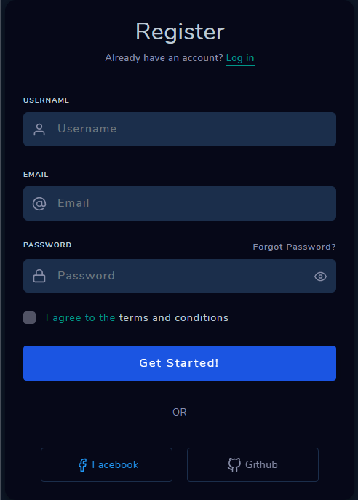

Figure-5: This prototype shows the sign-up section of the site. User have to register username, email and password to sign-up.

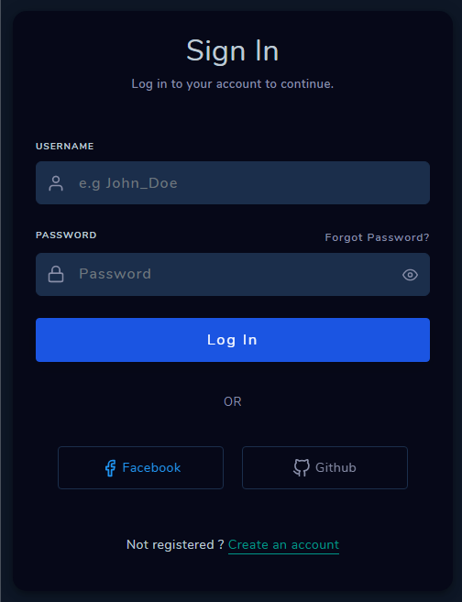

Figure-6: This prototype shows the sign-in section of the site. User have to enter username and password to login.

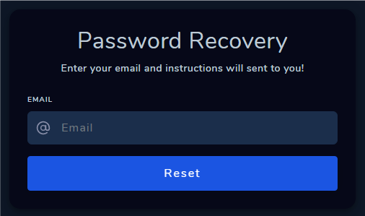

Figure-7: This prototype shows the password recovery section of the site. If a user forgets password, the updated credentials wills be sent on the email.

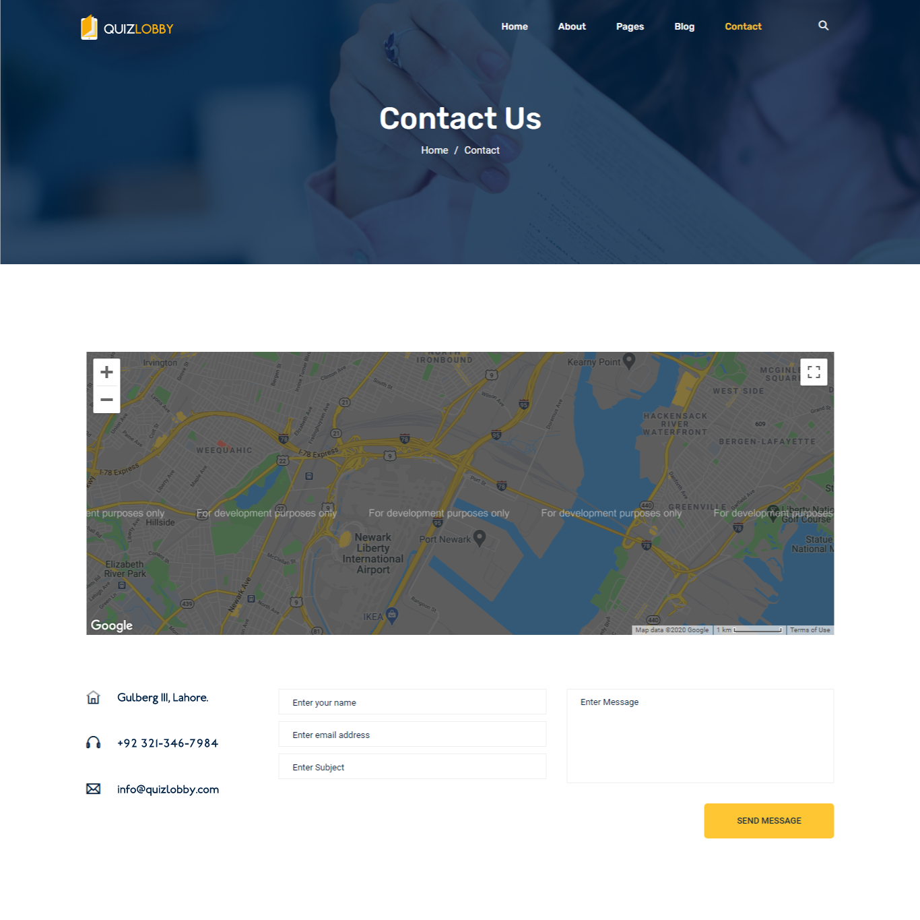

Figure-8: This prototype shows the contact us section of the site. User can send a message by filling the form or gets contact information.



Figure-9: This prototype shows the about us section of the site. User can get more information about our site.

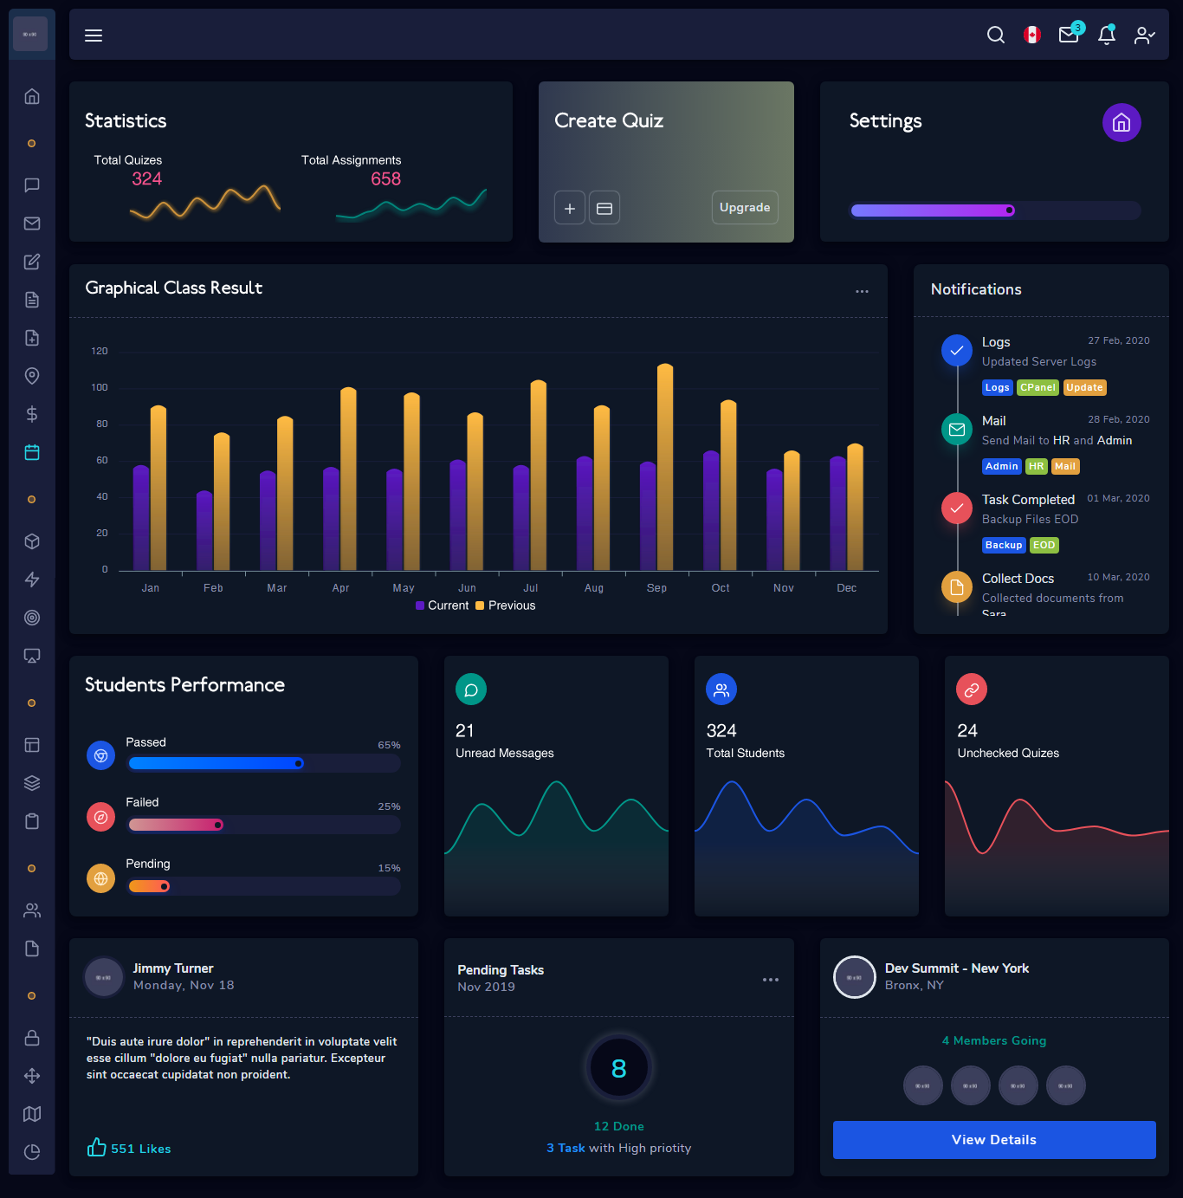

Figure-10: This prototype shows the teachers dashboard section of the site when teacher login into our portal. In this portal teacher can manage all the quizzes and records.

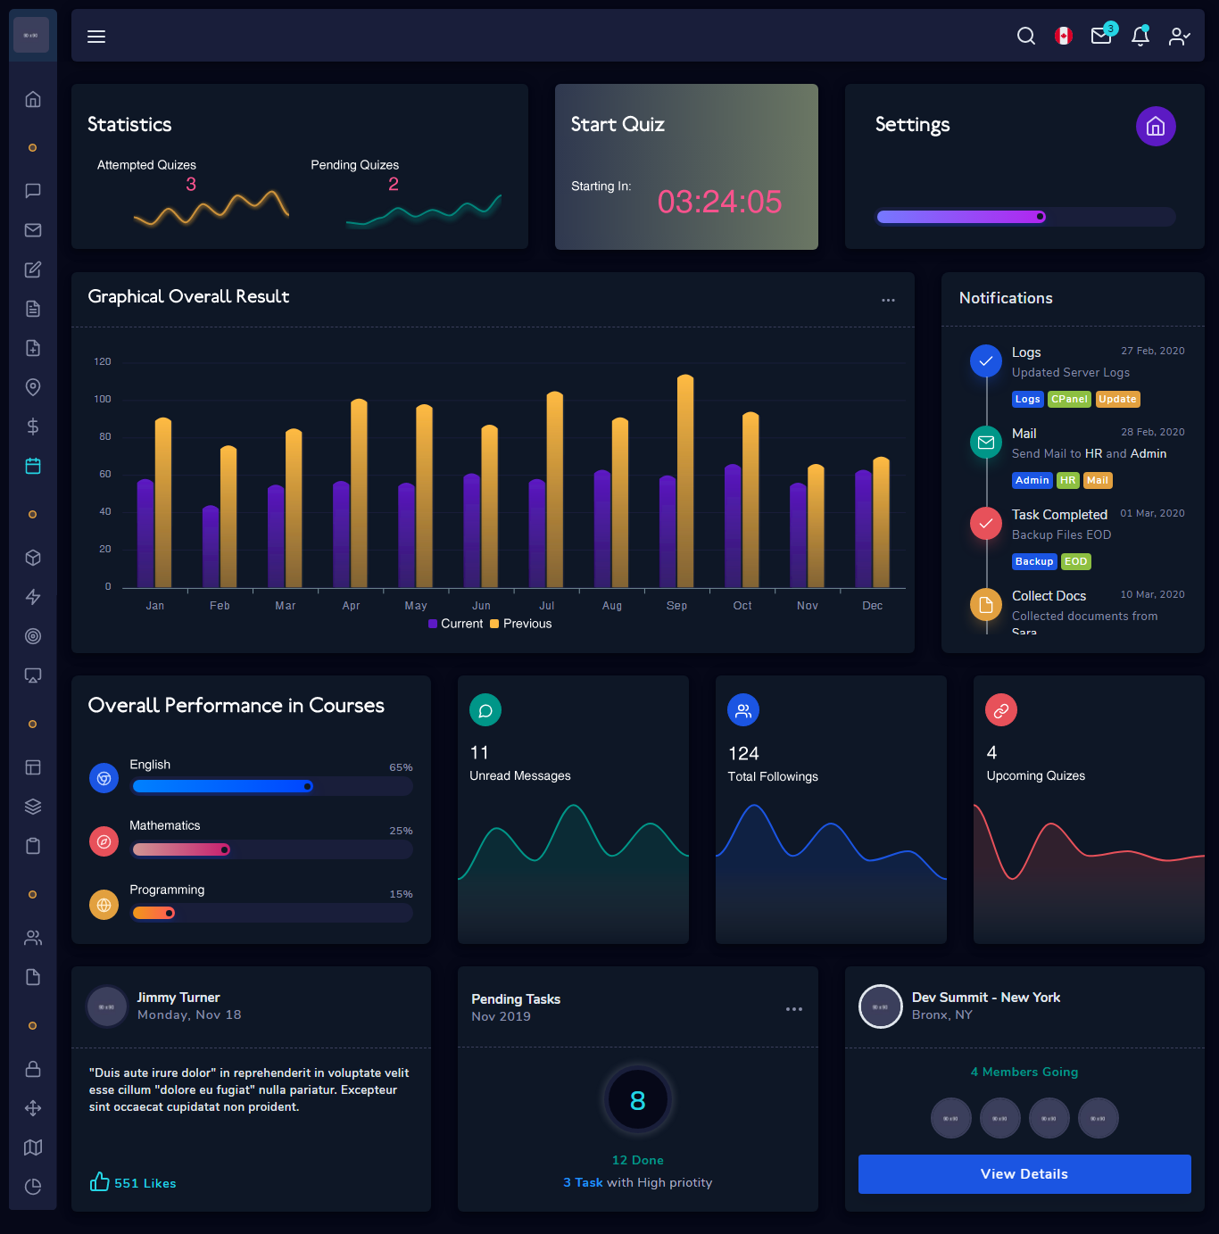

Figure-11: This prototype shows the students dashboard section of the site when student login into our portal. In this portal student can attempt and manage all the quizzes and records.

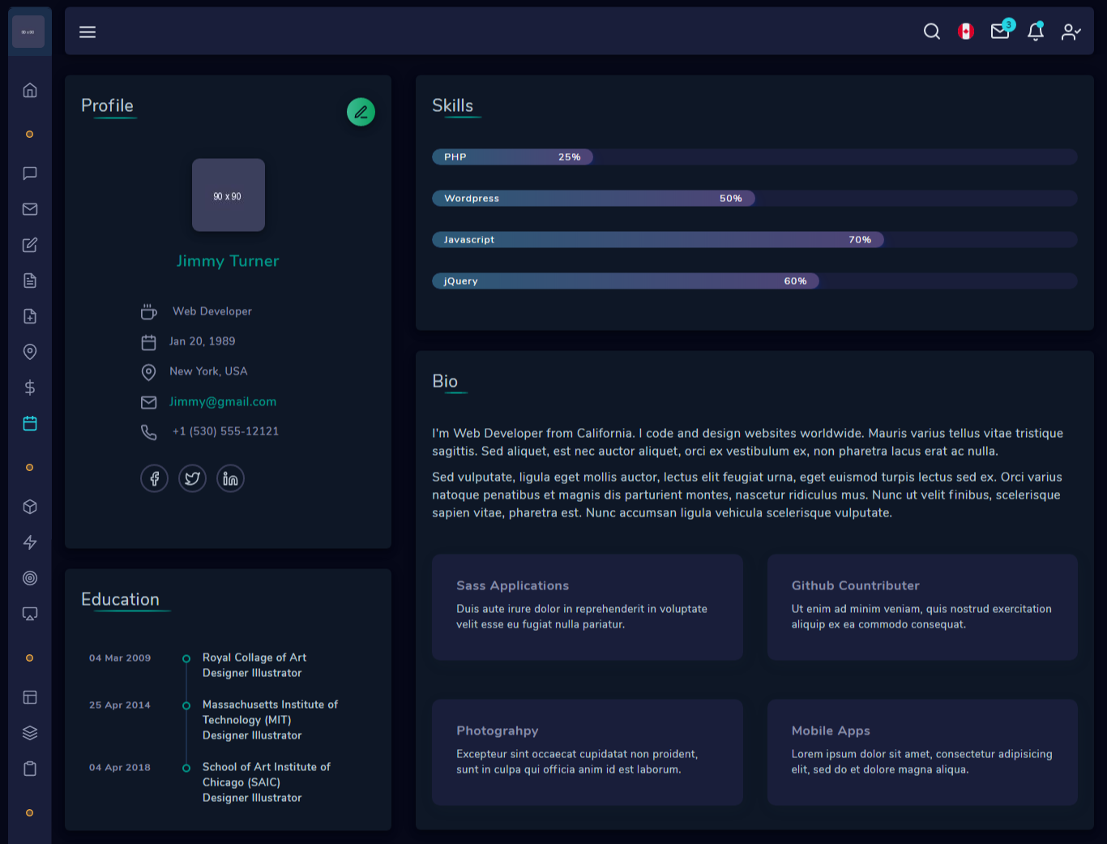

Figure-12: This prototype shows the profile section of the portal.

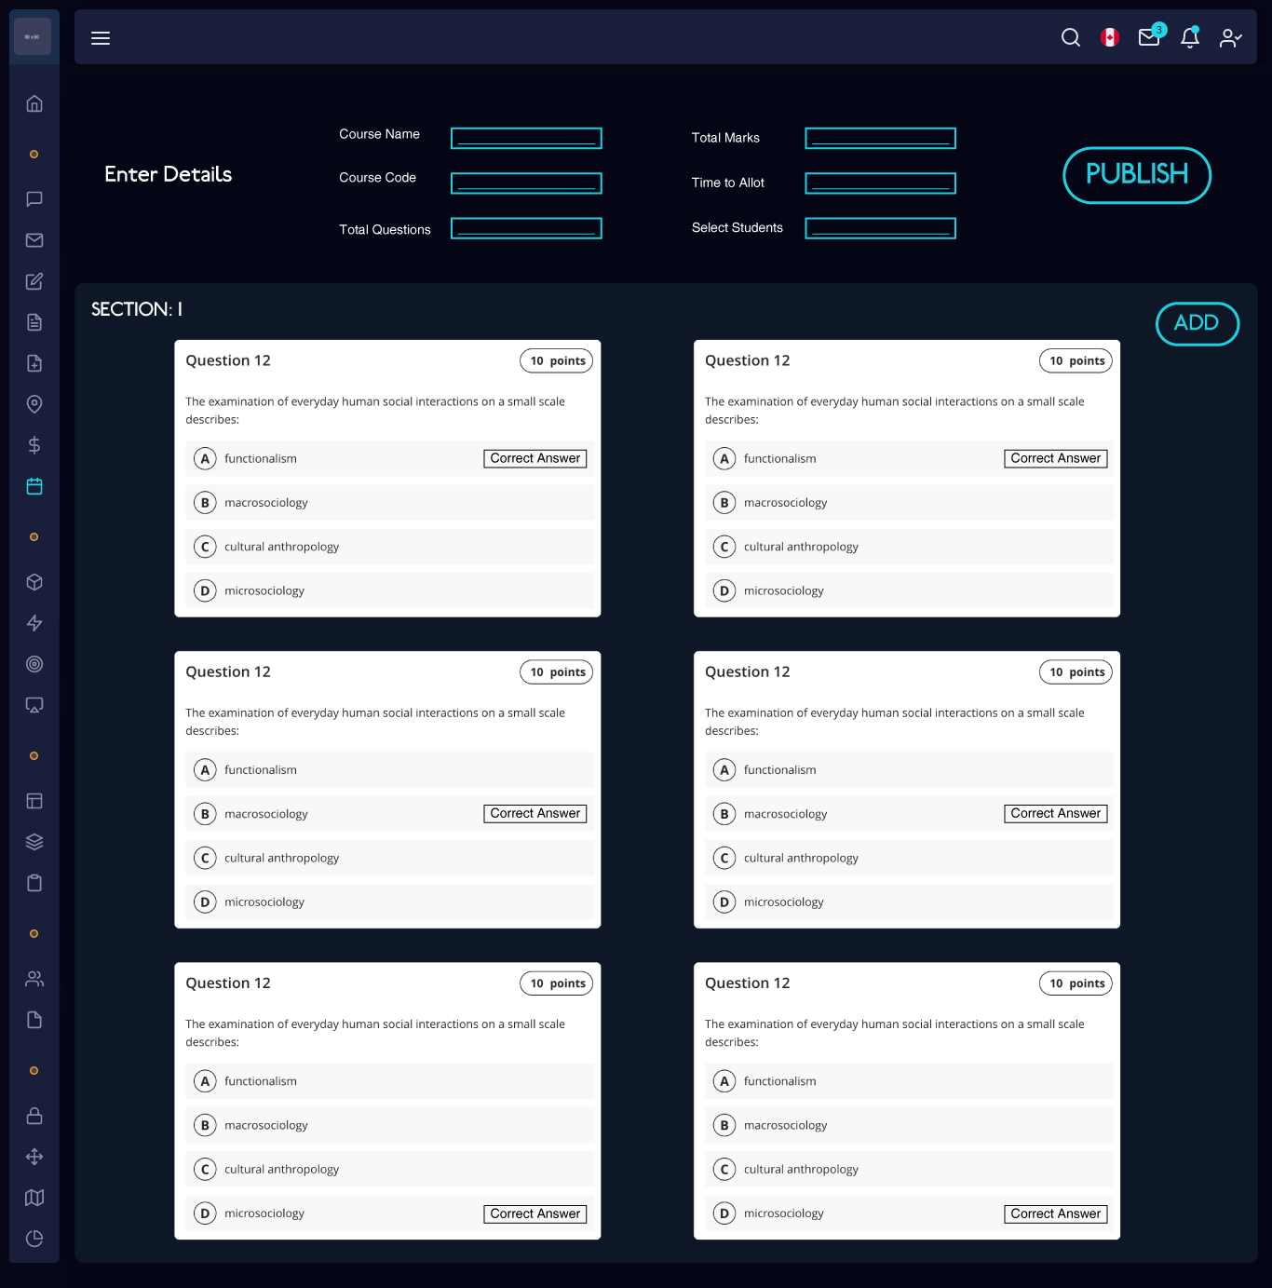

Figure-13: This prototype shows the teacher creating and publishing the exam section of the portal.

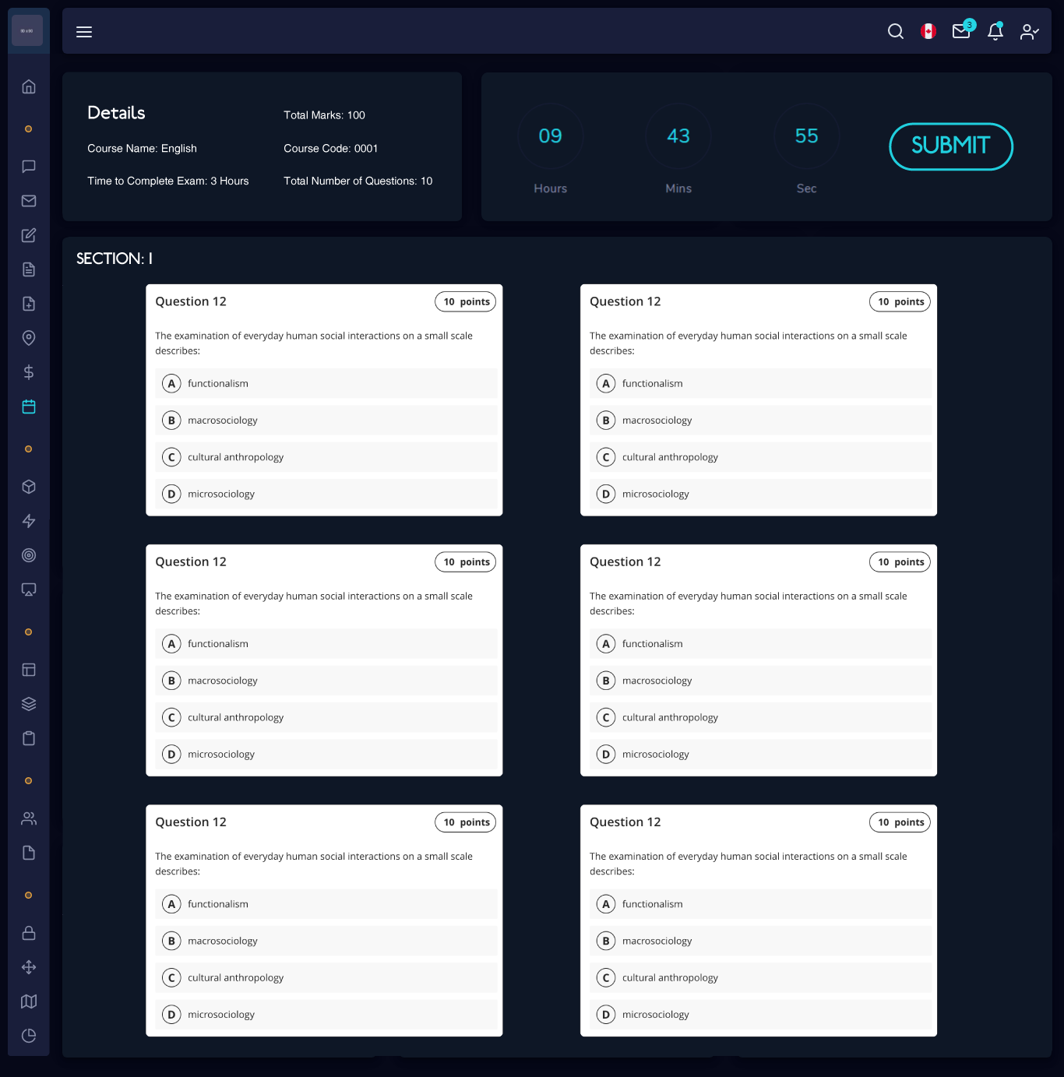

Figure-14: This prototype shows the student attempting and submitting the exam section of the portal.

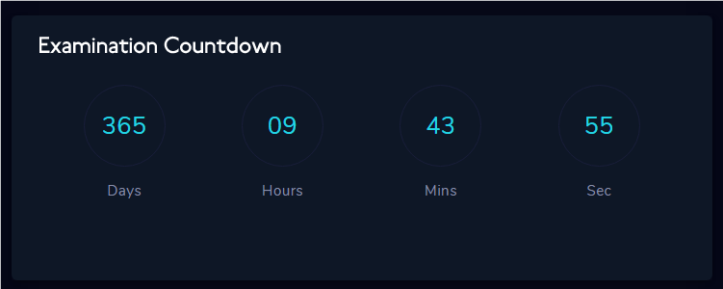

Figure-15: This prototype shows the timer section of the portal.

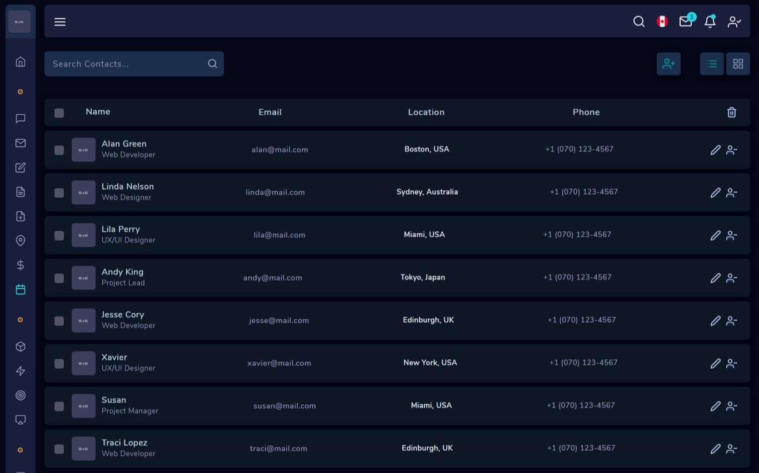

Figure-16: This prototype shows the following/student list section of the portal.

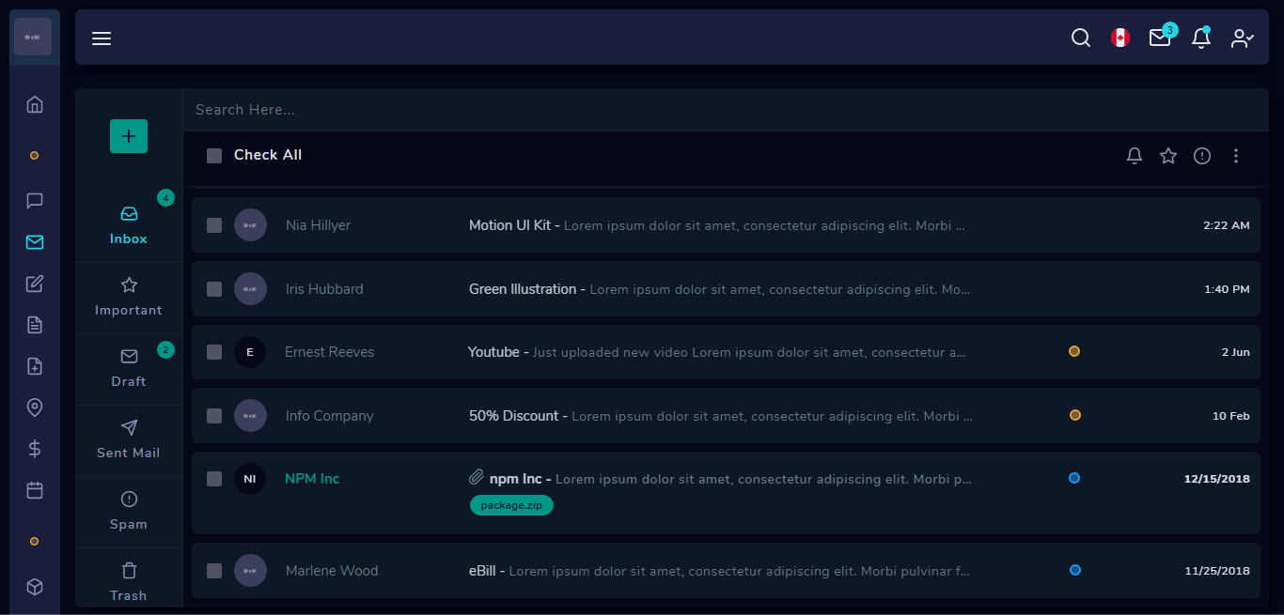

Figure-17: This prototype shows the mail section of the portal.

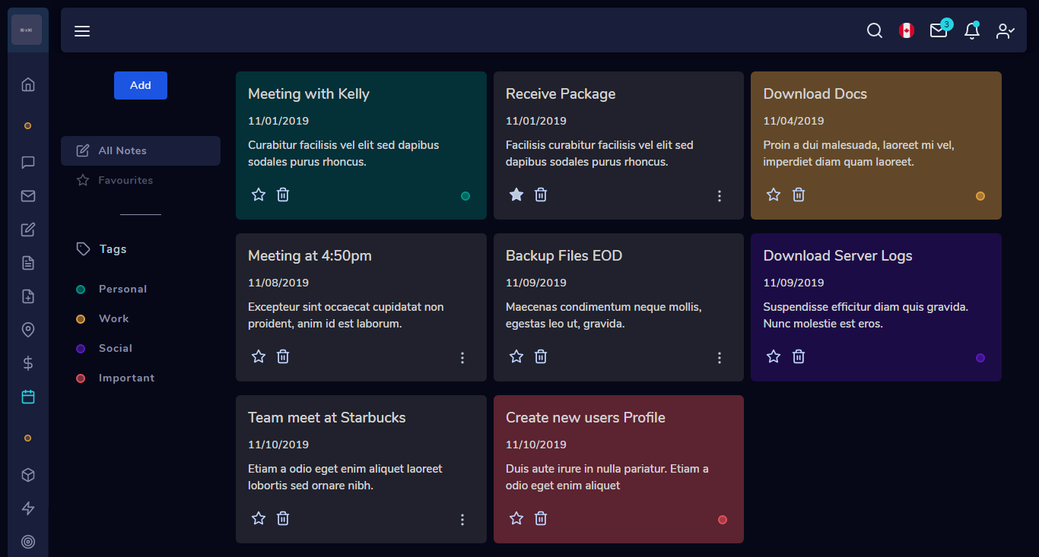

Figure-18: This prototype shows the notes section of the site.

# **4.** Data flow diagram (optional)

## **4.1 Data Flow Diagram Level 0**

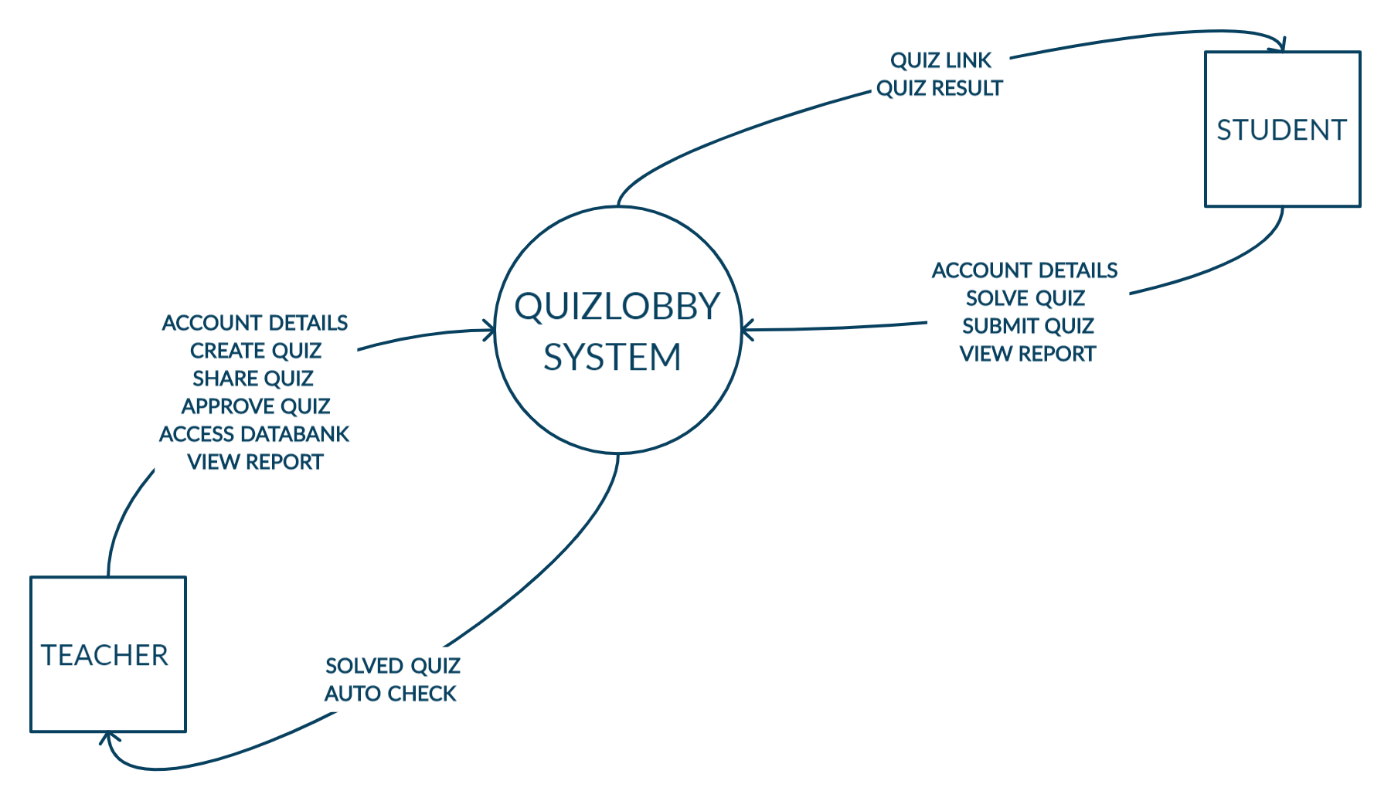

Figure-19: DFD Level 0

The main actors in our system are Teacher and Student. The teachers and the students will be able to sign up and login to the system by adding the account details. The teachers can create the quiz, access DataBank and share the link with their students. The students can solve and submit quizzes. The system will auto check the quizzes and send for approval to the teacher. Both actors can access the complete report and result.

## **4.2 Data Flow Diagram Level 1**

Figure-20: DFD Level 1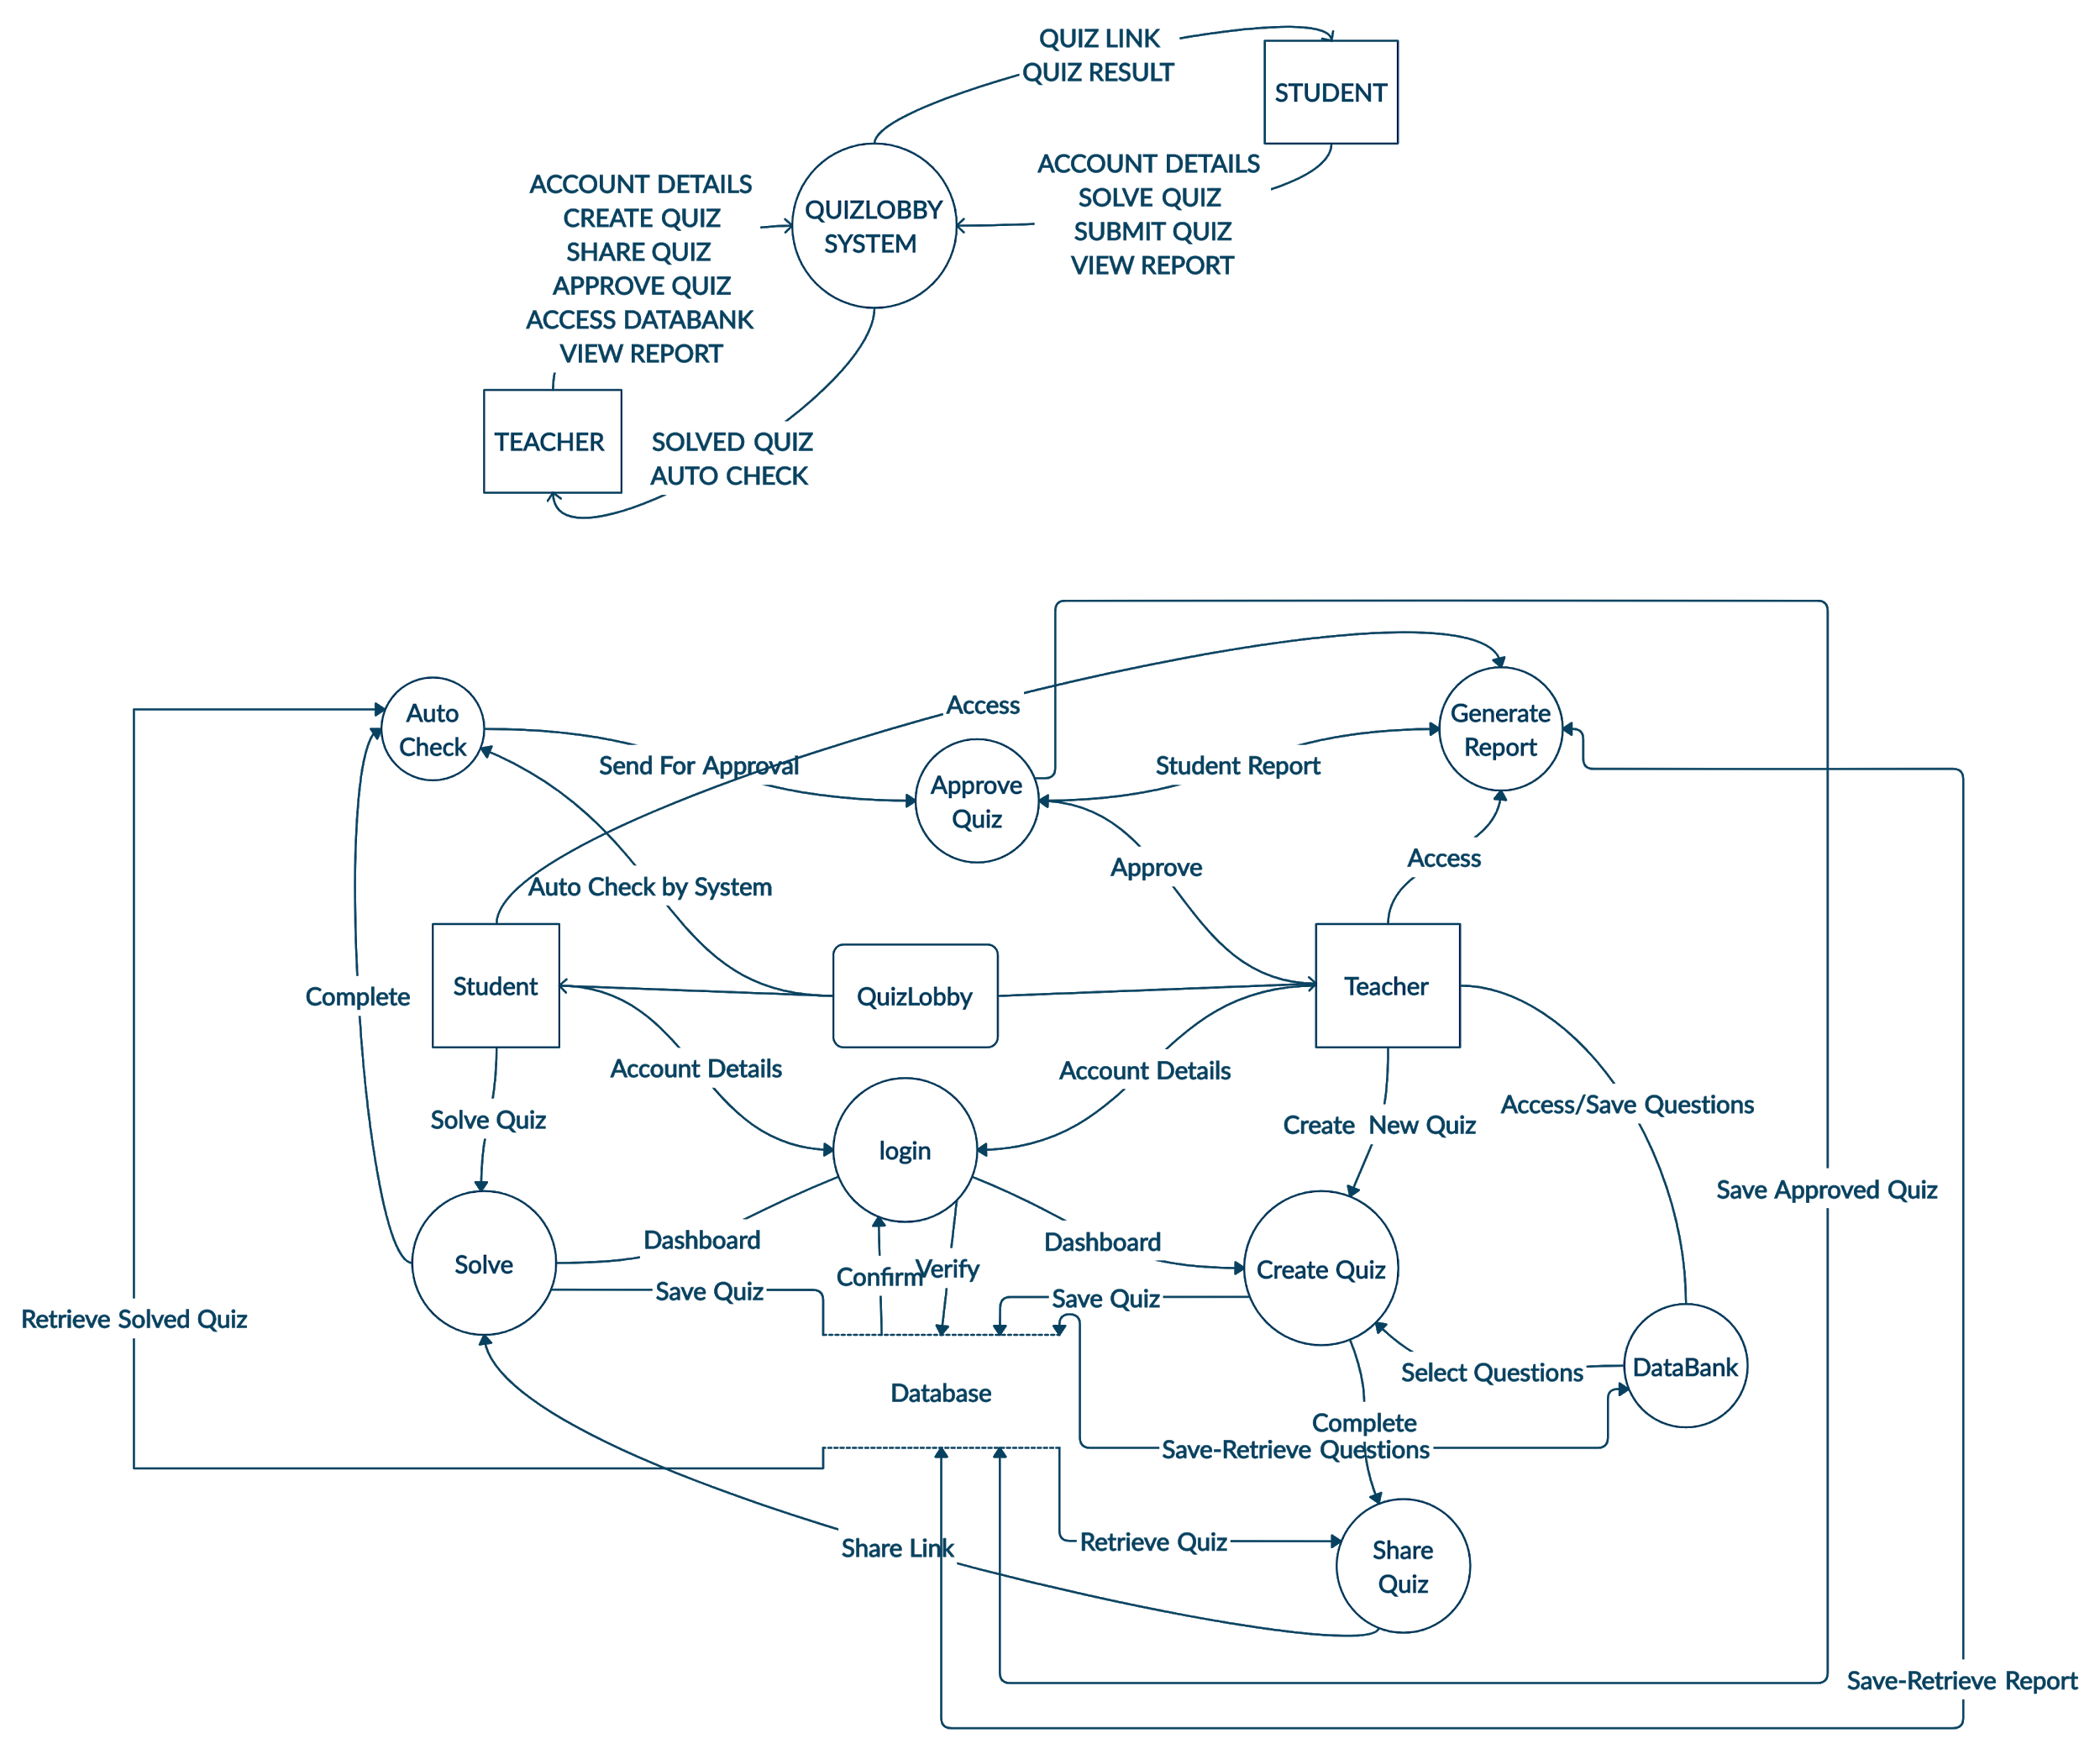

The student and teacher will be able to sign up and login to their accounts, leading them to their dashboards. The teachers can create a new quiz and can also select questions from the DataBank. Once the quiz has been created, the teacher can send the link to the students so they can attempt it. After the quiz has been completed and submitted, the system will auto check the quizzes and send it to the teacher for approval. Both the actors can access reports. During the whole process, a database will be used to save and retrieve the login details, questions, quizzes, and results.

# 5**.** System Diagram

## **5.1 System Architecture Diagram**

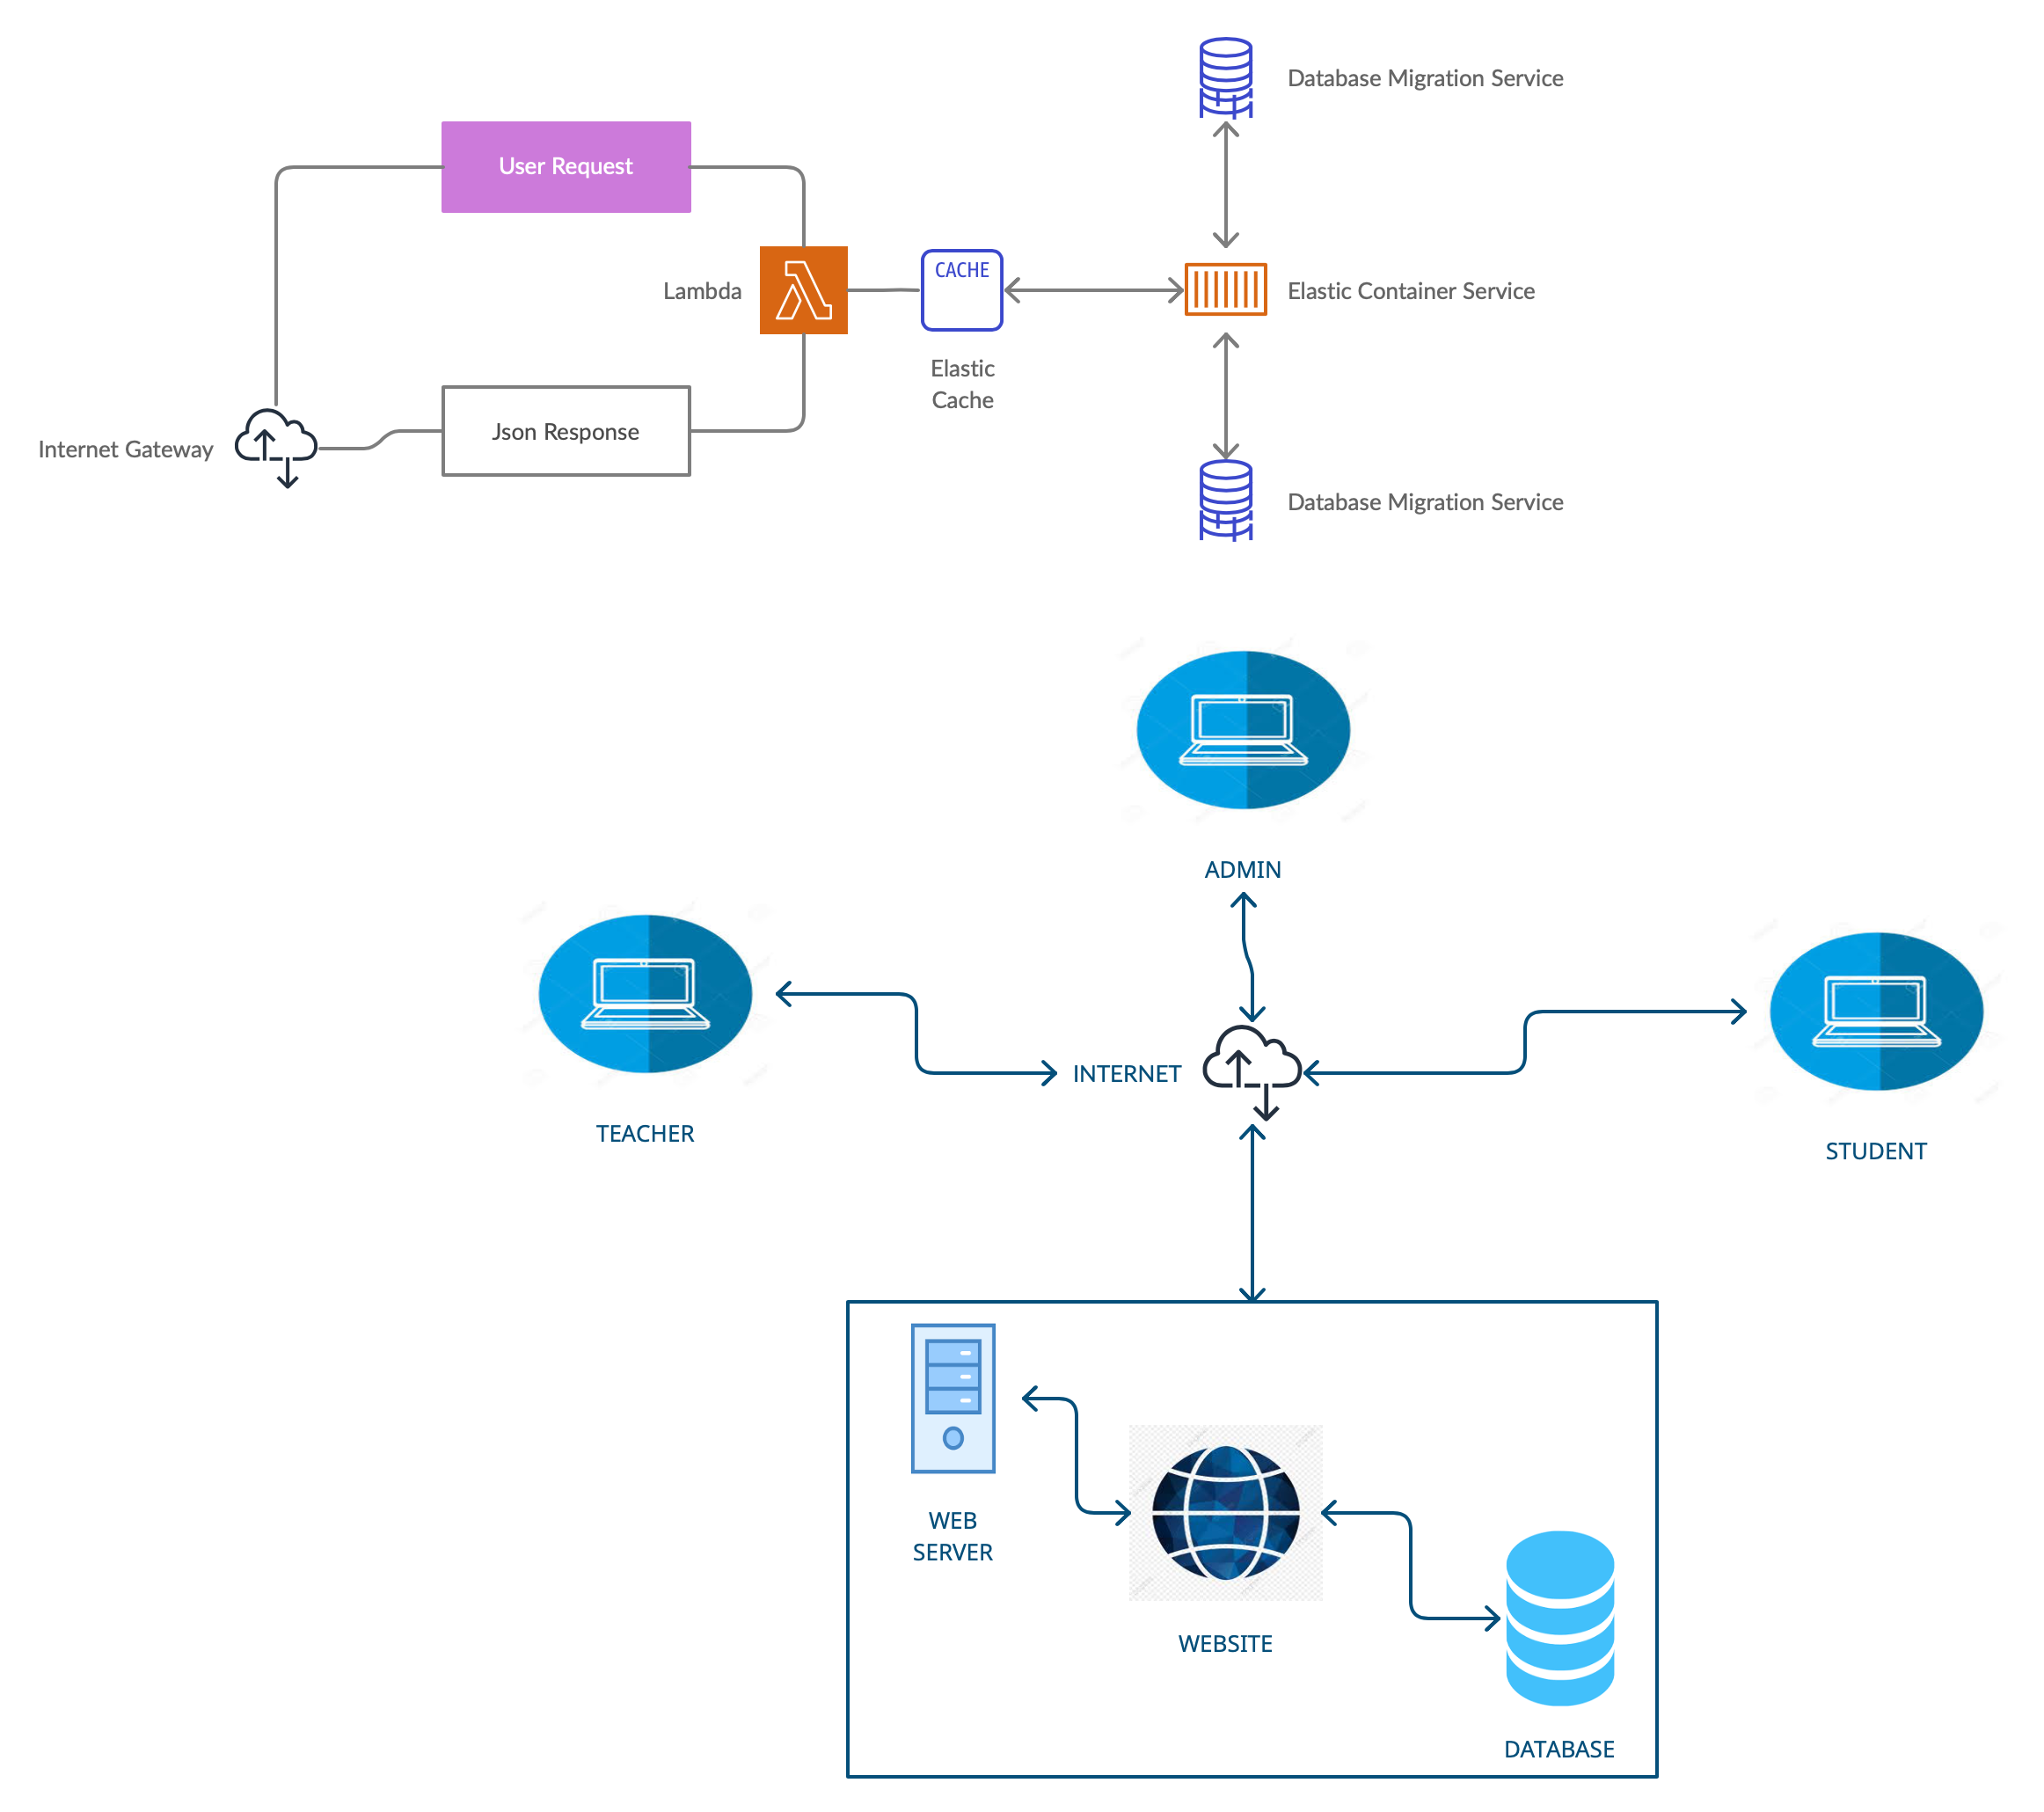

Figure-21: System Architecture Diagram

This system architecture diagram shows that the Admin(us), Teachers, and Students will be able to access the website through the internet. Once we give the command, web server will allow the access and redirect us to the website. All the data that we store will be stored in the database and the user can access the data from there.

## **5.2 Class Diagram**

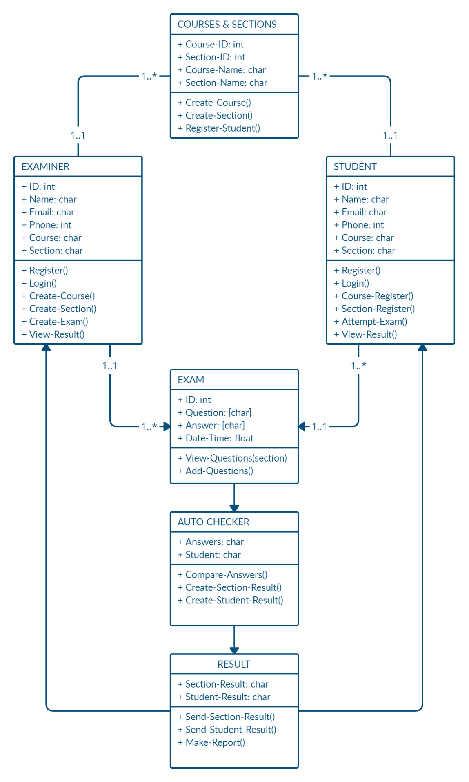

Figure-22: Class Diagram

**5.3 Sequence Diagrams**

**5.3.1 Login**

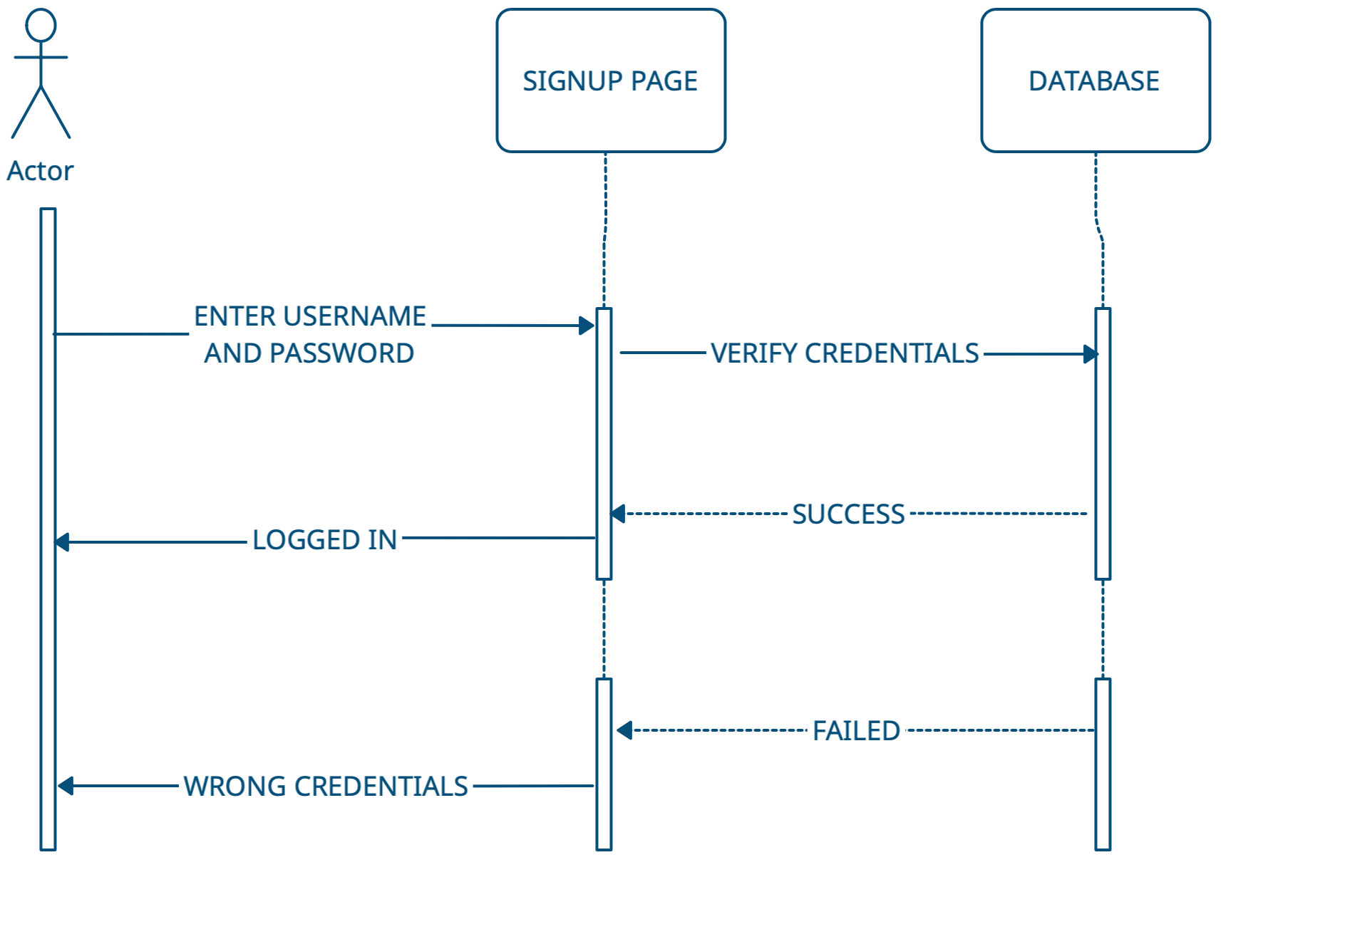

Figure-23: Login

The sequence diagram shows that the user will enter the username and password which will then be verified whether it exists in our database or not. If it exists and the credentials are correct, user will be given a message saying “Logged In”. If the credentials are wrong or do not exist, verification will be failed and a message will appear saying “Wrong Credentials”.

**5.3.2 Signup**

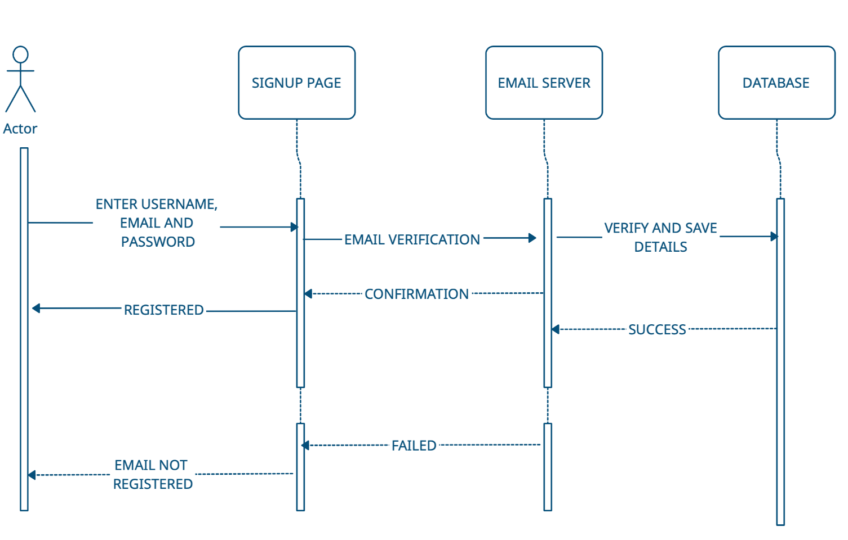

Figure-24: Signup

To signup, the user will enter their email, password, and the username they want. The email will be verified at the email server. Once the email is confirmed, the details will be saved on the database and the user will get a message “Registered”. On the other hand, if it the email does not exist, the email confirmation from email server will be failed and the user will get a message saying “Email Not Registered”.

**5.3.3 Create Quiz**

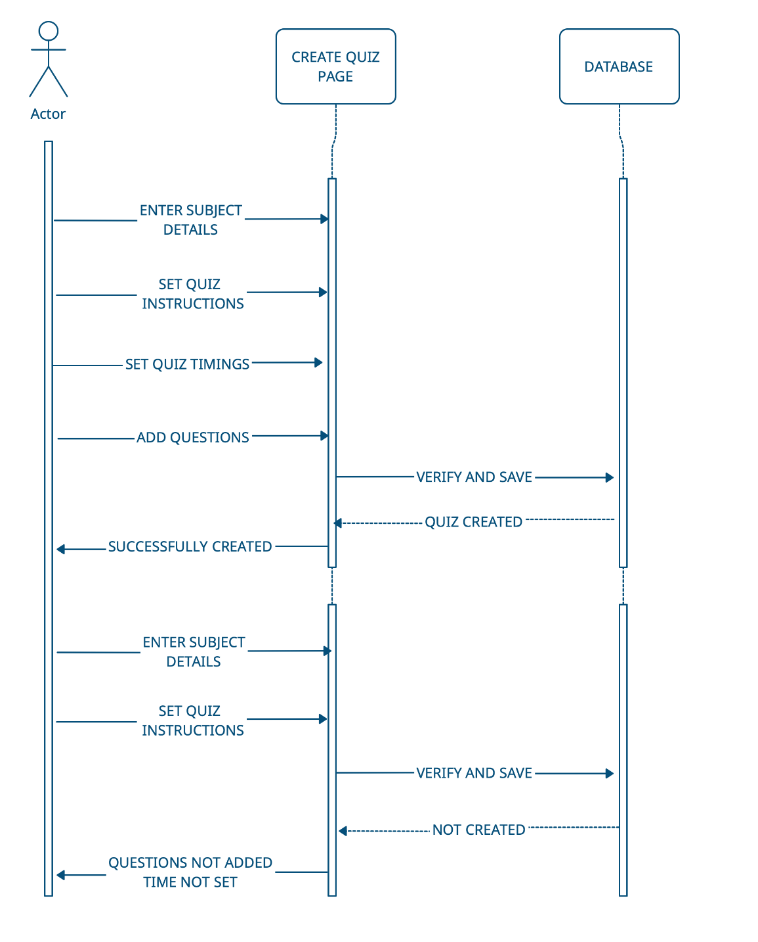

Figure-25: Create Quiz

The teacher will enter the course details, quiz instructions, set the quiz timings and add questions. Once she hits the “Save” button, the data will be verified, checked if all the information required is filled up, and saved into the database. The teacher will receive a message saying “Quiz Successfully Created”. If questions aren’t added and time isn’t set, the details will not be saved into database and the user will receive a message “Questions not added/Time not set”.

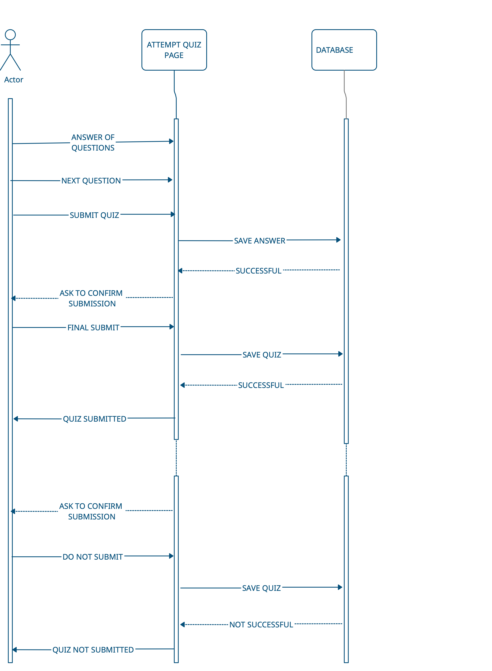**5.3.4 Attempt Quiz**

Figure-26: Attempt Quiz

The student will answer the question and click on the “Next Question” button. Once he is done with answering all the questions, he will click on “Submit Quiz”. The quiz will be saved into the database and the student will receive a message asking whether he wants to confirm his submission. The student will click on “Final Submit” if he is finished with the quiz, the quiz will be saved into the Database and a message will pop up saying “Quiz Submitted”. If the student won’t agree with final submission the quiz will not be saved in database and won’t be submitted.

**5.4 Other UMLs**

**5.5 Activity Diagram**

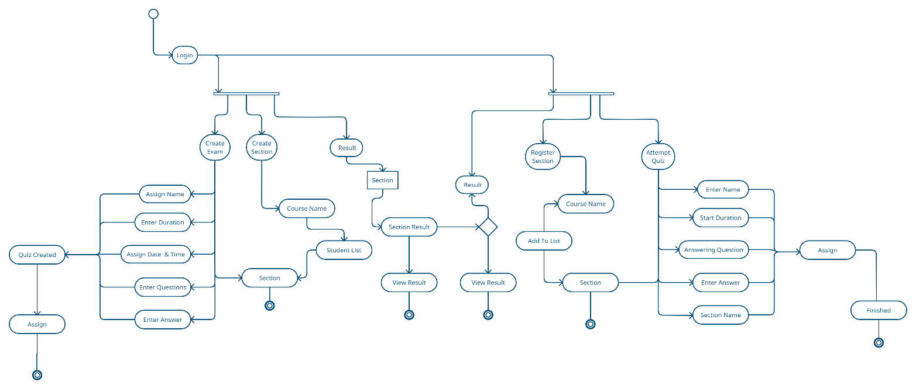

Figure-27: Activity Diagram

**5.6 ERD**

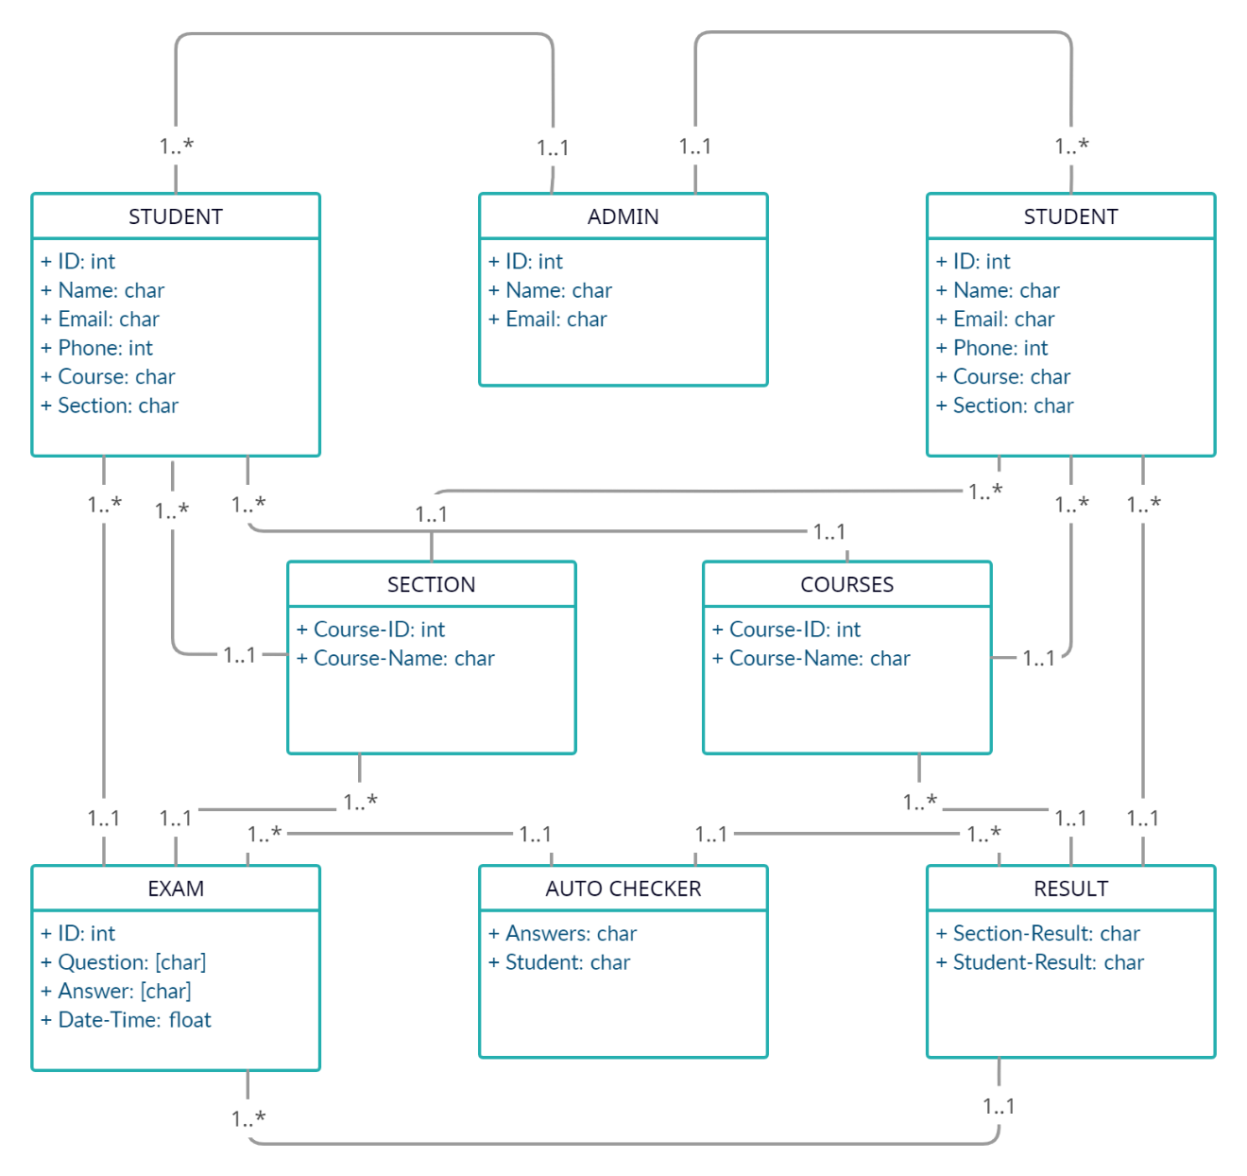

Figure-28: ER Diagram

# **6.** Implementation Details

## **6.1 Development Setup**

List of technologies and tools that we used for the development:

* Front-End Development - Html, CSS
* Back-End Development - Python
* Framework - Django
* Database – SQLite 3

**6.2 Deployment Setup**

We haven’t deployed the website yet. However, we are planning to make it go live in the near future.

**6.3 Algorithms**

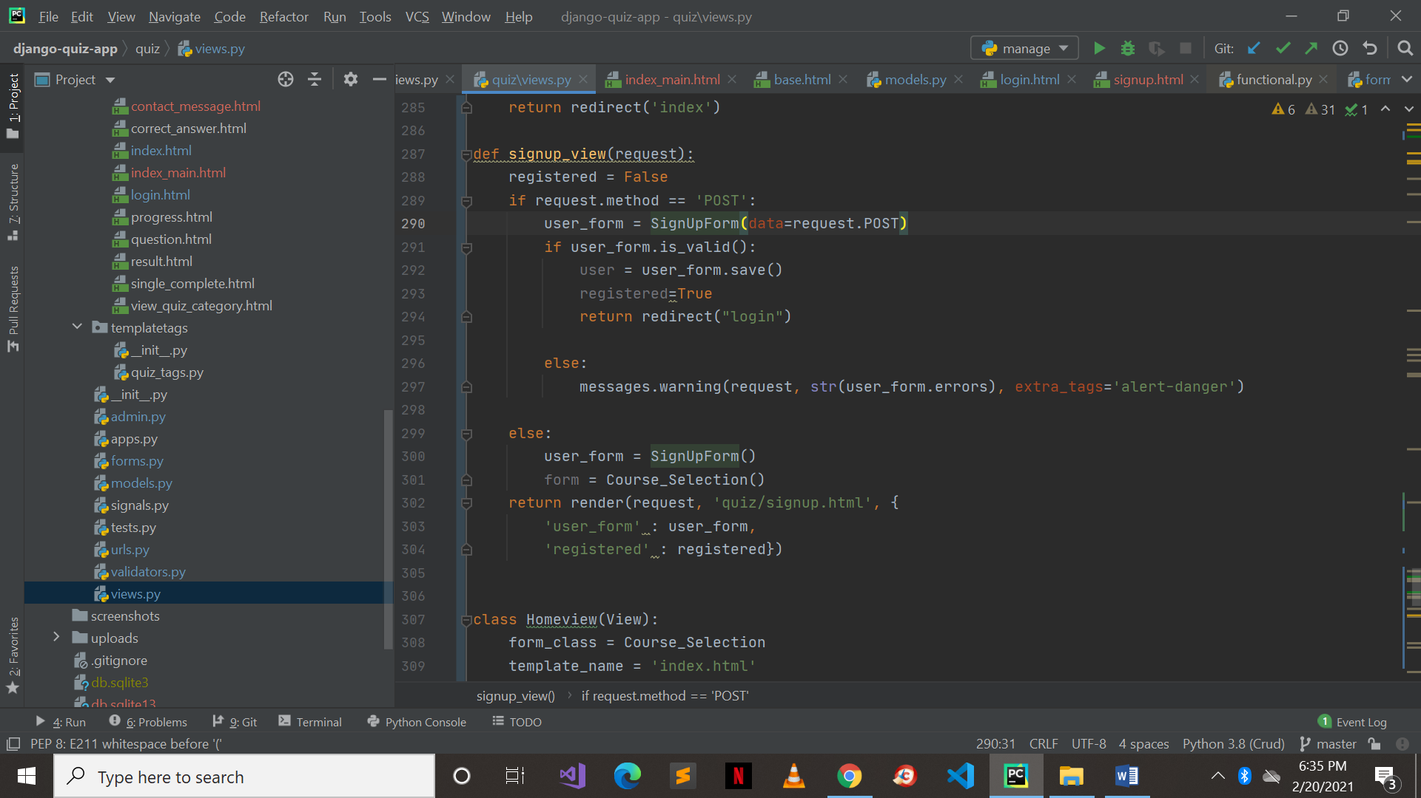

Figure-29: Signup

This is the algorithm for Signing up into QuizLobby.

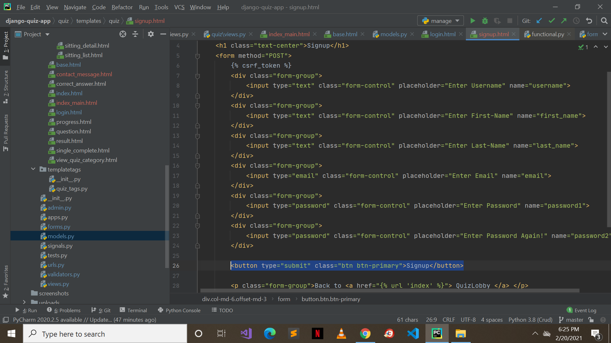

Figure-30: Signup Front end

Front end algorithm for Signup.

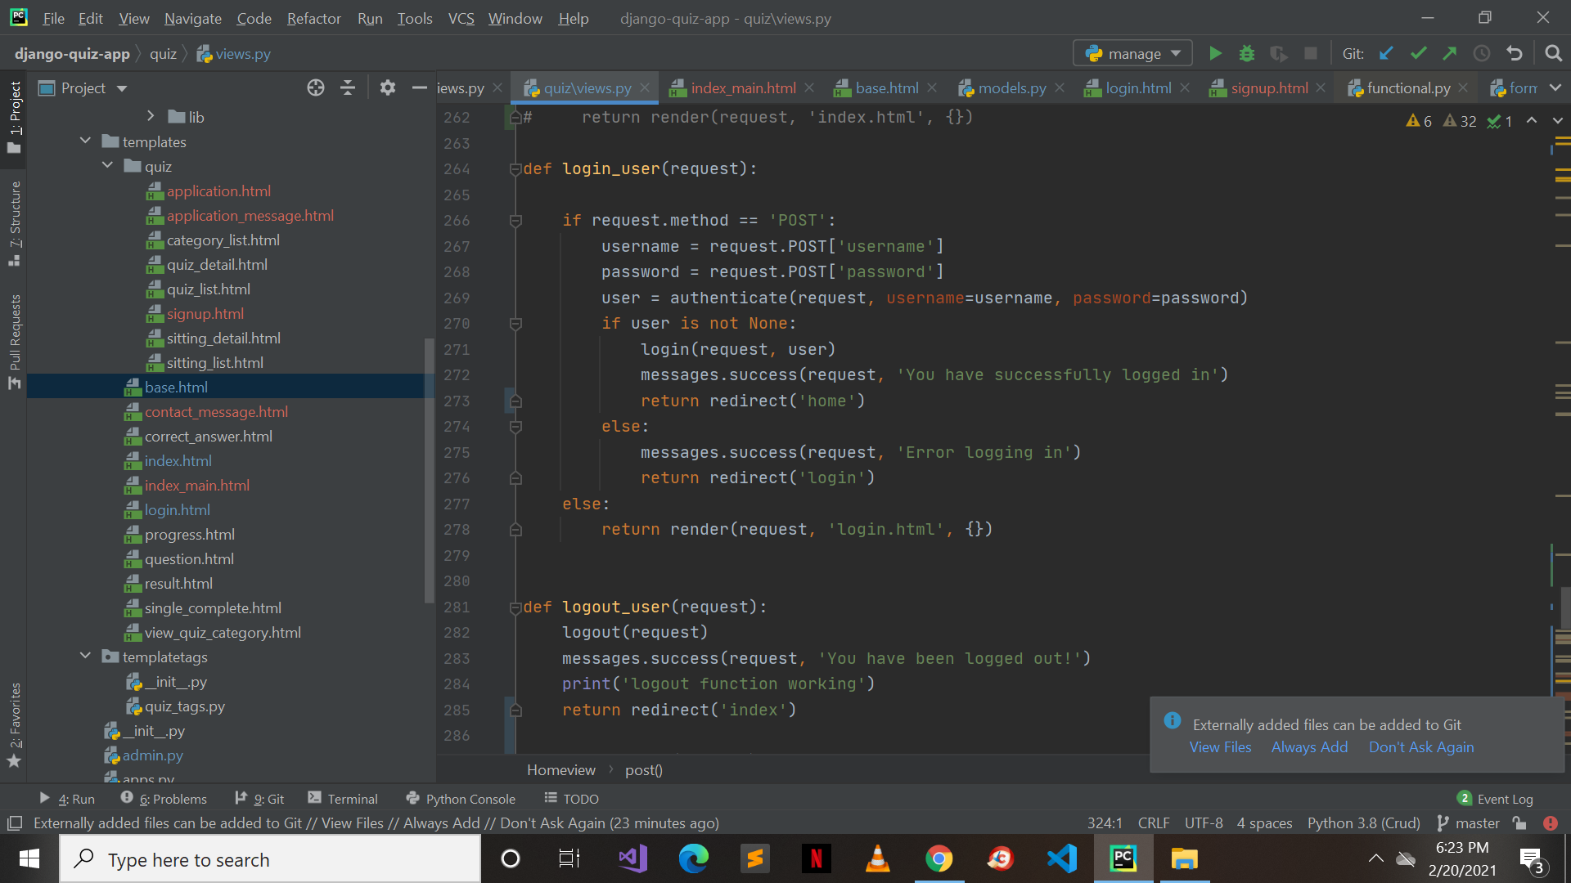

Figure-31: Login

This is the algorithm for Login and Logout of QuizLobby.

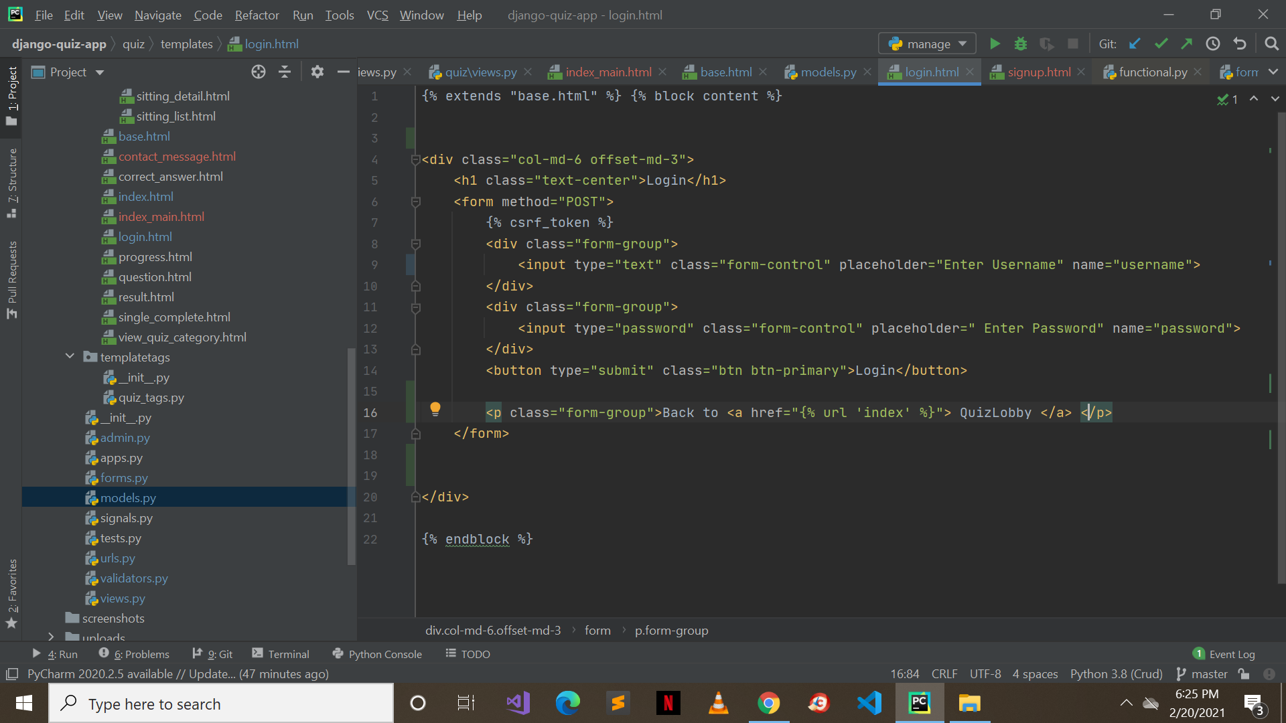

Figure-32: Login Front end

Front end algorithm for Login.

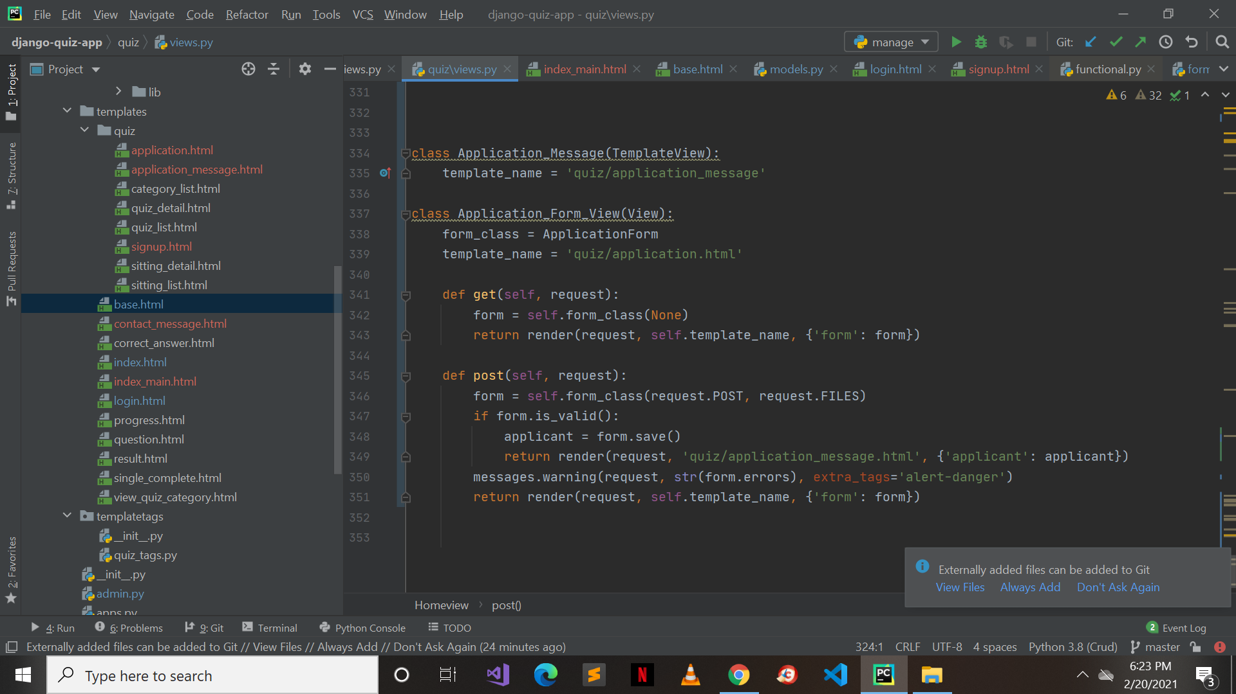

Figure-33: application Form

This is the algorithm for Application Form.

**6.4 Constraints**

**6.4.1 Assumptions**

* User has a laptop/desktop
* User has internet connection to access the website
* User should be registered either as a teacher to a student to perform further tasks
* Users should have correct credentials to their account

**6.4.2 System Constraints**

* Website is solely made for laptop/desktop. Not accessible otherwise
* Cannot be access without the internet connection
* A browser should be installed in the system

**6.4.3 Restrictions**

* Not accessible without internet connection
* Login credentials should be valid in order to use the functionalities
* User email should be unique to register successfully
* Student cannot create quizzes or check the quizzes
* Teachers will not be able to solve quizzes

**6.4.4 Limitations**

* User will not be able to register/signup if already registered.
* Password should be strong
* Students cannot access each other’s results

# **7.** Testing

## **7.1 Extended Test Cases**

Table 18: User Signup

|  |  |  |  |  |  |
| --- | --- | --- | --- | --- | --- |
| **ID:** 1 | | | Designed by: Amanullah Awan | | |
| **Module Name**: User Signup | | | Design Date: 15-01-2021 | | |
| **Priority:** High | | | Executed by: Amanullah Awan | | |
| **Test Name:** Signup | | | Execution Date: 22-01-2021 | | |
| **Objective:** Testing signup on website | | | | | |
| **Pre-condition:** User has never signed up before | | | | | |
| Step# | Test Step | Test Data | Expected Result | Actual Result | Status(Pass/Fail) |
| 1 | Hover to homepage |  |  |  |  |
| 2 | Click on SIGNUP button |  |  |  |  |
| 3 | Enter credentials and data for signup | Name: Xyz  Username:xyz28  Email:xyz@example.com  Password:wearehere@28 |  |  |  |
| 4 | Then click Signup or press enter |  | User added to the DB | User can login now and access the website | Pass |
| **Post-Condition:** User can login now and access the website. | | | | | |

Table 19: Login

|  |  |  |  |  |  |
| --- | --- | --- | --- | --- | --- |
| **ID:** 2 | | | Designed by: Amanullah Awan | | |
| **Module Name**: Login | | | Design Date: 15-01-2021 | | |
| **Priority:** High | | | Executed by: Amanullah Awan | | |
| **Test Name:** Login | | | Execution Date: 22-01-2021 | | |
| **Objective:** Testing login on website | | | | | |
| **Pre-condition:** User have already signed up before | | | | | |
| Step# | Test Step | Test Data | Expected Result | Actual Result | Status(Pass/Fail) |
| 1 | Hover to homepage |  |  |  |  |
| 2 | Click on LOGIN button |  |  |  |  |
| 3 | Enter valid credentials | Username:xyz28  Password:wearehere@28 |  |  |  |
| 4 | Then click login or press enter |  | User should be able to login | User logged in and accessed the website | Pass |
| **Post-Condition:** User logged in and his/her data is being displayed. | | | | | |

Table 20: Teacher Application Form

|  |  |  |  |  |  |
| --- | --- | --- | --- | --- | --- |
| **ID:** 3 | | | Designed by: Amanullah Awan | | |
| **Module Name**: Teacher Application Form | | | Design Date: 15-01-2021 | | |
| **Priority:** High | | | Executed by: Amanullah Awan | | |
| **Test Name:** Teacher Signup | | | Execution Date: 22-01-2021 | | |
| **Objective:** Testing application form on website | | | | | |
| **Pre-condition:** User has never applied | | | | | |
| Step# | Test Step | Test Data | Expected Result | Actual Result | Status(Pass/Fail) |
| 1 | Hover to homepage |  |  |  |  |
| 2 | Click on APPLY US button |  |  |  |  |
| 3 | Enter credentials and data for applying | Name: Teacherfoo  Email:teacherfoo@example.com  Contact: 0300123456  Course: English  Cv: Resume123.docx |  |  |  |
| 4 | Then click Apply |  | User request received in DB | User data sent for processing | Pass |
| **Post-Condition:** After processing the user will be able to access the admin panel with some limitations and for creating quizzes. | | | | | |

Table 21: Add Questions

|  |  |  |  |  |  |
| --- | --- | --- | --- | --- | --- |
| **ID:** 4 | | | Designed by: Amanullah Awan | | |
| **Module Name**: Add Questions | | | Design Date: 15-01-2021 | | |
| **Priority:** High | | | Executed by: Amanullah Awan | | |
| **Test Name:** Adding Questions to Quiz | | | Execution Date: 22-01-2021 | | |
| **Objective:** Testing adding the questions to the quiz | | | | | |
| **Pre-condition:** User logged in to the Django admin panel | | | | | |
| Step# | Test Step | Test Data | Expected Result | Actual Result | Status(Pass/Fail) |
| 1 | Click on the add button of the MCQS table |  |  |  |  |
| 2 | Add question details |  |  |  |  |
| 3 | Click on Save button | Question: What is my name?  Explanation: It’s my name  Answer order: Content  Content: Option1: Mani (Correct)  Option2: Xyz  Option3: Abc | Question is been added to question table and can be selected at quiz | Question is being selected | Pass |
| **Post-Condition:** Question is ready for the selection for the quiz. | | | | | |

Table 22: Create Quiz

|  |  |  |  |  |  |
| --- | --- | --- | --- | --- | --- |
| **ID:** 5 | | | Designed by: Amanullah Awan | | |
| **Module Name**: Create Quiz | | | Design Date: 15-01-2021 | | |
| **Priority:** High | | | Executed by: Amanullah Awan | | |
| **Test Name:** Quiz Creation | | | Execution Date: 22-01-2021 | | |
| **Objective:** Testing creation of quiz on website | | | | | |
| **Pre-condition:** Logged in into Django admin panel | | | | | |
| Step# | Test Step | Test Data | Expected Result | Actual Result | Status(Pass/Fail) |
| 1 | Hover to admin panel |  |  |  |  |
| 2 | Login to Django admin panel |  |  |  |  |
| 3 | Click on ADD QUIZ+ button |  |  |  |  |
| 4 | Add details for the quiz | Start-datetime:22-01-2021  16:00:00  End-datetime:22-01-2021  16:30:00  Course rel: Web  Title: 1st Quiz  Description: Chapter1  User friendly url: first-quiz  Random order: True  Single Attempt: True  Max Questions:1  Exam Paper:1  Category:1st Chapter  Pass Mark: 100%  Draft: False  Success Text: Hurrah!  Fail Text: Try Again!  Questions: What is my name? |  |  |  |
| 5 | Then click save |  | Quiz has been created | Quiz info displayed to user | Pass |
| **Post-Condition:** Quiz has been created and saved and been displayed to the user (Student) on his/her list. | | | | | |

Table 23: Edit Quiz

|  |  |  |  |  |  |
| --- | --- | --- | --- | --- | --- |
| **ID:** 6 | | | Designed by: Amanullah Awan | | |
| **Module Name**: Edit Quiz | | | Design Date: 15-01-2021 | | |
| **Priority:** Medium | | | Executed by: Amanullah Awan | | |
| **Test Name:** Updating Quiz | | | Execution Date: 22-01-2021 | | |
| **Objective:** Testing editing of quiz | | | | | |
| **Pre-condition:** Logged in into Django admin panel | | | | | |
| Step# | Test Step | Test Data | Expected Result | Actual Result | Status(Pass/Fail) |
| 1 | Hover to admin panel |  |  |  |  |
| 2 | Login to Django admin panel |  |  |  |  |
| 3 | Click on that quiz you want to edit |  |  |  |  |
| 4 | Edit the details | Start-datetime:22-01-2021  16:00:00  End-datetime:22-01-2021  16:40:00  Course rel: Web  Title: 1st Quiz  Description: Chapter1  User friendly url: first-quiz  Random order: True  Single Attempt: True  Max Questions:1  Exam Paper:1  Category:1st Chapter  Pass Mark: 50%  Draft: False  Success Text: Hurrah!  Fail Text: Try Again!  Questions: What is my name? |  |  |  |
| 5 | Then click save |  | Quiz has been updated | Quiz info displayed to user | Pass |
| **Post-Condition:** Quiz has been updated and saved and been displayed to the user (Student) on his/her list. | | | | | |

Table 24: Delete Quiz

|  |  |  |  |  |  |  |
| --- | --- | --- | --- | --- | --- | --- |
| **ID:** 7 | | | Designed by: Amanullah Awan | | | |
| **Module Name**: Delete Quiz | | | Design Date: 15-01-2021 | | | |
| **Priority:** High | | | Executed by: Amanullah Awan | | | |
| **Test Name:** Quiz Deletion | | | Execution Date: 22-01-2021 | | | |
| **Objective:** Testing Deletion of quiz | | | | | | |
| **Pre-condition:** Logged in to Django admin panel and created quiz before | | | | | | |
| Step# | Test Step | Test Data | | Expected Result | Actual Result | Status(Pass/Fail) |
| 1 | Click on that quiz you want to delete |  | |  |  |  |
| 2 | Click on Delete |  | |  |  |  |
| 3 | Then click on I am sure! |  | | Quiz deleted from DB | Quiz deleted from the list | Pass |
| **Post-Condition:** Quiz will be deleted from the list and DB. | | | | | | |

Table 25: Select Course

|  |  |  |  |  |  |
| --- | --- | --- | --- | --- | --- |
| **ID:** 8 | | | Designed by: Amanullah Awan | | |
| **Module Name**: Select Course | | | Design Date: 15-01-2021 | | |
| **Priority:** High | | | Executed by: Amanullah Awan | | |
| **Test Name:** Course Selection | | | Execution Date: 22-01-2021 | | |
| **Objective:** Testing selection of the course on website | | | | | |
| **Pre-condition:** User logged in to website | | | | | |
| Step# | Test Step | Test Data | Expected Result | Actual Result | Status(Pass/Fail) |
| 1 | Hover to dropdown menu |  |  |  |  |
| 2 | Then select course |  |  |  |  |
| 3 | Then click on Enroll | Course Selected: Web Development | Selected Course is added to DB | User is enrolled to the course | Pass |
| **Post-Condition:** User has been enrolled into the course. | | | | | |

Table 26: Attempt Quiz

|  |  |  |  |  |  |
| --- | --- | --- | --- | --- | --- |
| **ID:** 9 | | | Designed by: Amanullah Awan | | |
| **Module Name**: Attempt Quiz | | | Design Date: 15-01-2021 | | |
| **Priority:** High | | | Executed by: Amanullah Awan | | |
| **Test Name:** Attempting Quiz | | | Execution Date: 22-01-2021 | | |
| **Objective:** Testing the attempt of quiz on website | | | | | |
| **Pre-condition:** User has logged in and there are no empty quizzes in the list | | | | | |
| Step# | Test Step | Test Data | Expected Result | Actual Result | Status(Pass/Fail) |
| 1 | Click on Quizzes from navbar |  |  |  |  |
| 2 | Click on Start Quiz link |  |  |  |  |
| 3 | Select the correct answer option for question |  |  |  |  |
| 4 | Then click Submit |  | User answers processed and result was saved | User progress and result of the quiz is displayed | Pass |
| **Post-Condition:** After the quiz attempt, progress or result will be shown to the user at the end. | | | | | |

Table 27: View Progress

|  |  |  |  |  |  |
| --- | --- | --- | --- | --- | --- |
| **ID:** 10 | | | Designed by: Amanullah Awan | | |
| **Module Name**: View Progress | | | Design Date: 15-01-2021 | | |
| **Priority:** Medium | | | Executed by: Amanullah Awan | | |
| **Test Name:** Progress of User | | | Execution Date: 22-01-2021 | | |
| **Objective:** Testing the progress of user | | | | | |
| **Pre-condition:** User is logged in and has attempted at least one quiz | | | | | |
| Step# | Test Step | Test Data | Expected Result | Actual Result | Status(Pass/Fail) |
| 1 | Click on Progress from navbar |  | User progress data is retrieved and displayed | User progress has been displayed | Pass |
| **Post-Condition:** User progress details has been displayed. | | | | | |

Table 28: Contact Us

|  |  |  |  |  |  |
| --- | --- | --- | --- | --- | --- |
| **ID:** 11 | | | Designed by: Amanullah Awan | | |
| **Module Name**: Contact Us | | | Design Date: 15-01-2021 | | |
| **Priority:** Medium | | | Executed by: Amanullah Awan | | |
| **Test Name:** Contact Us | | | Execution Date: 22-01-2021 | | |
| **Objective:** Testing contact us so that we can receive messages from the user | | | | | |
| **Pre-condition:** User should have a valid email address | | | | | |
| Step# | Test Step | Test Data | Expected Result | Actual Result | Status(Pass/Fail) |
| 1 | Hover to homepage |  |  |  |  |
| 2 | Click on Contact US button |  |  |  |  |
| 3 | Enter details for contact us | Name: Amanullah  Email:dexent.mani28@gmail.com Subject: Teacher Application!  Message: How can I apply as a teacher? |  |  |  |
| 4 | Then click Send Message |  | Data is been added to DB | User message has been received | Pass |
| **Post-Condition:** The users will get to know that their message has been received and the team will contact them very soon! | | | | | |

**7.2 Decision Table**

**7.2.1 Code Snippet**

**User Teacher:**

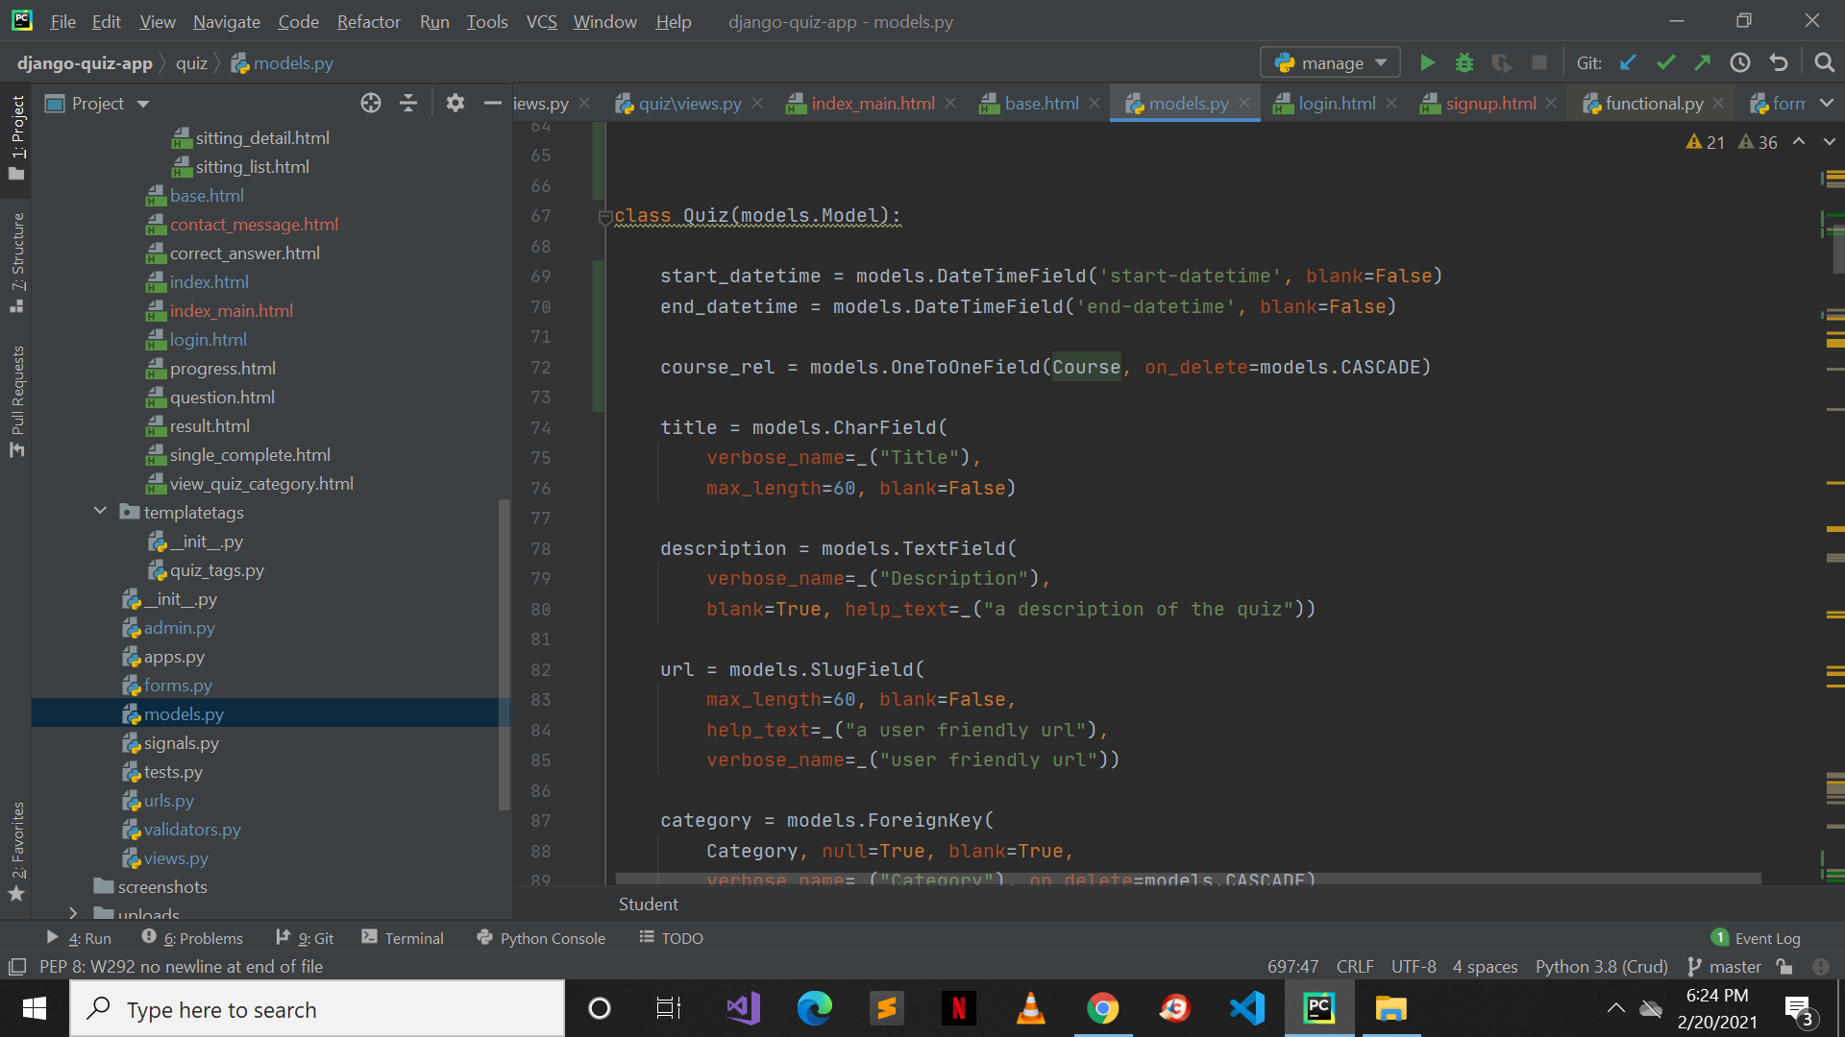

Figure-34: Create a Quiz

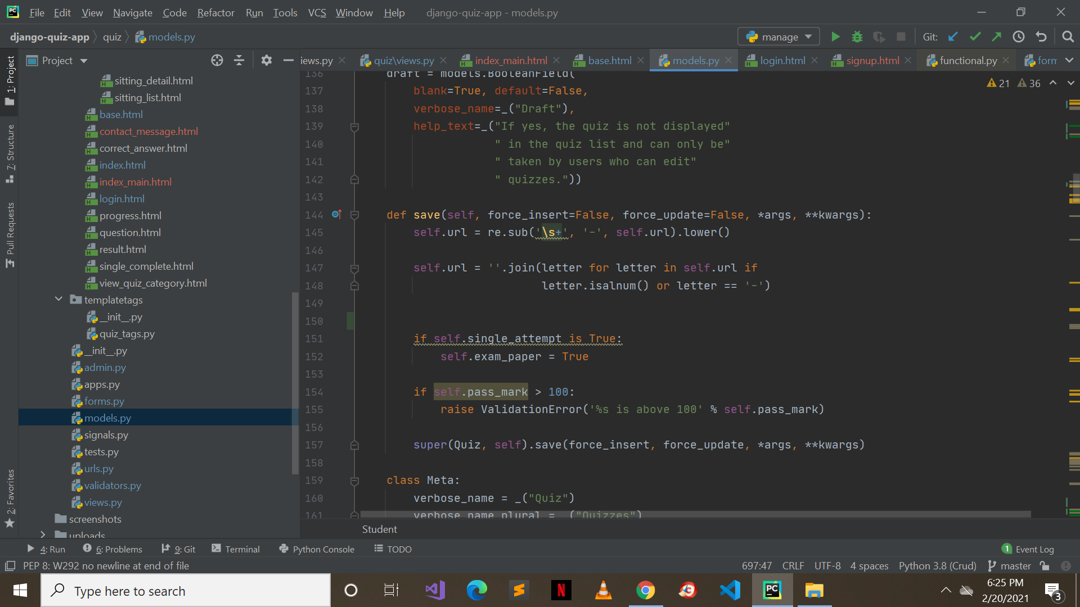

Figure-35: Save Created Quiz

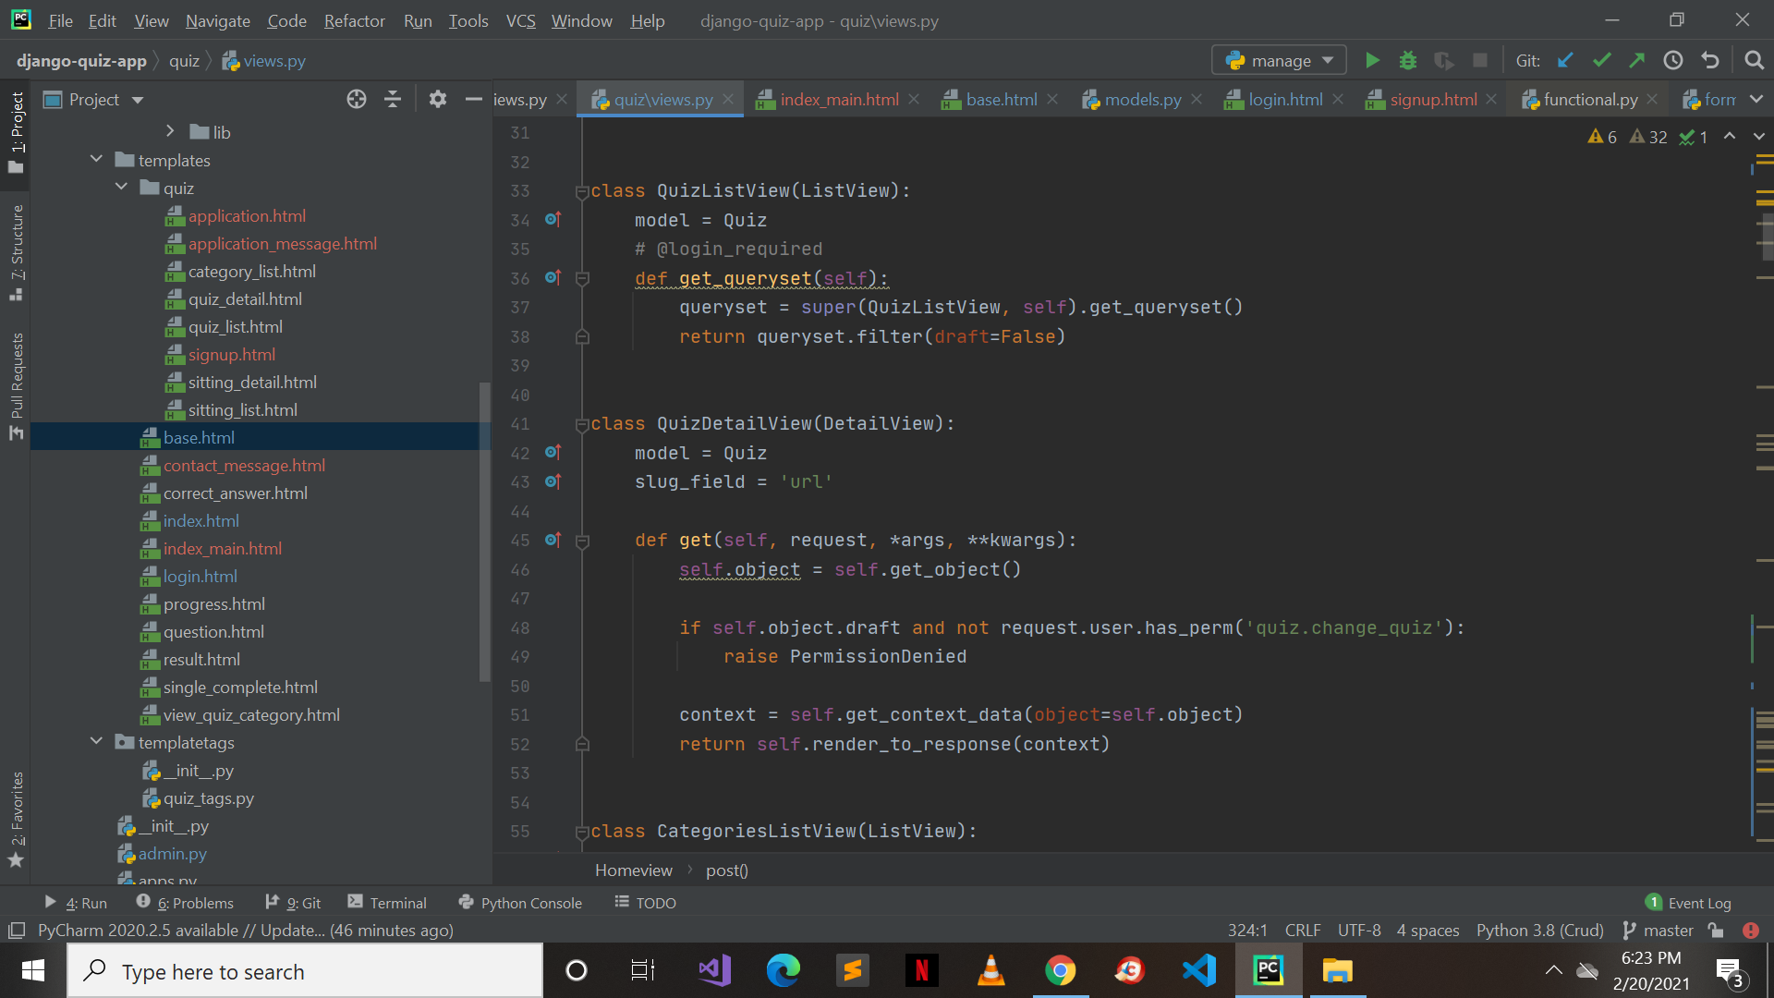

Figure-36: Quiz List

**User: Student**

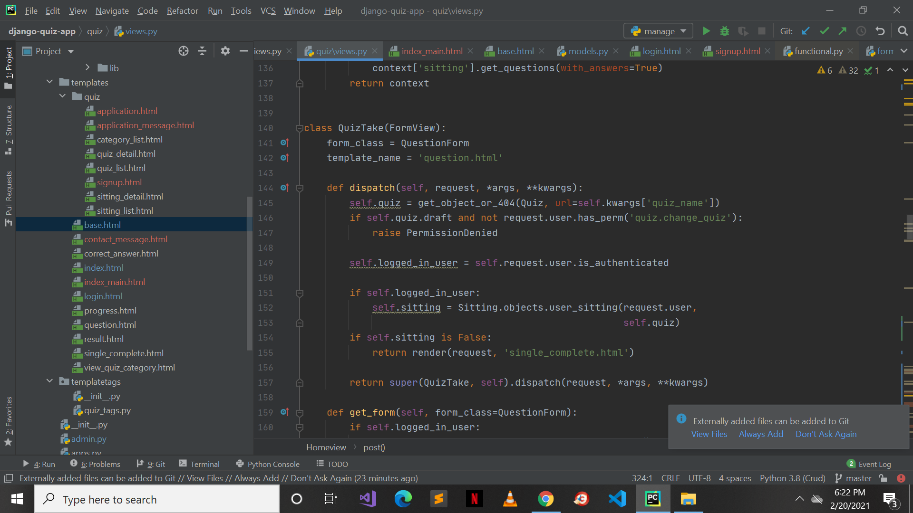

Figure-37: Attempt Quiz



Figure-39: Login

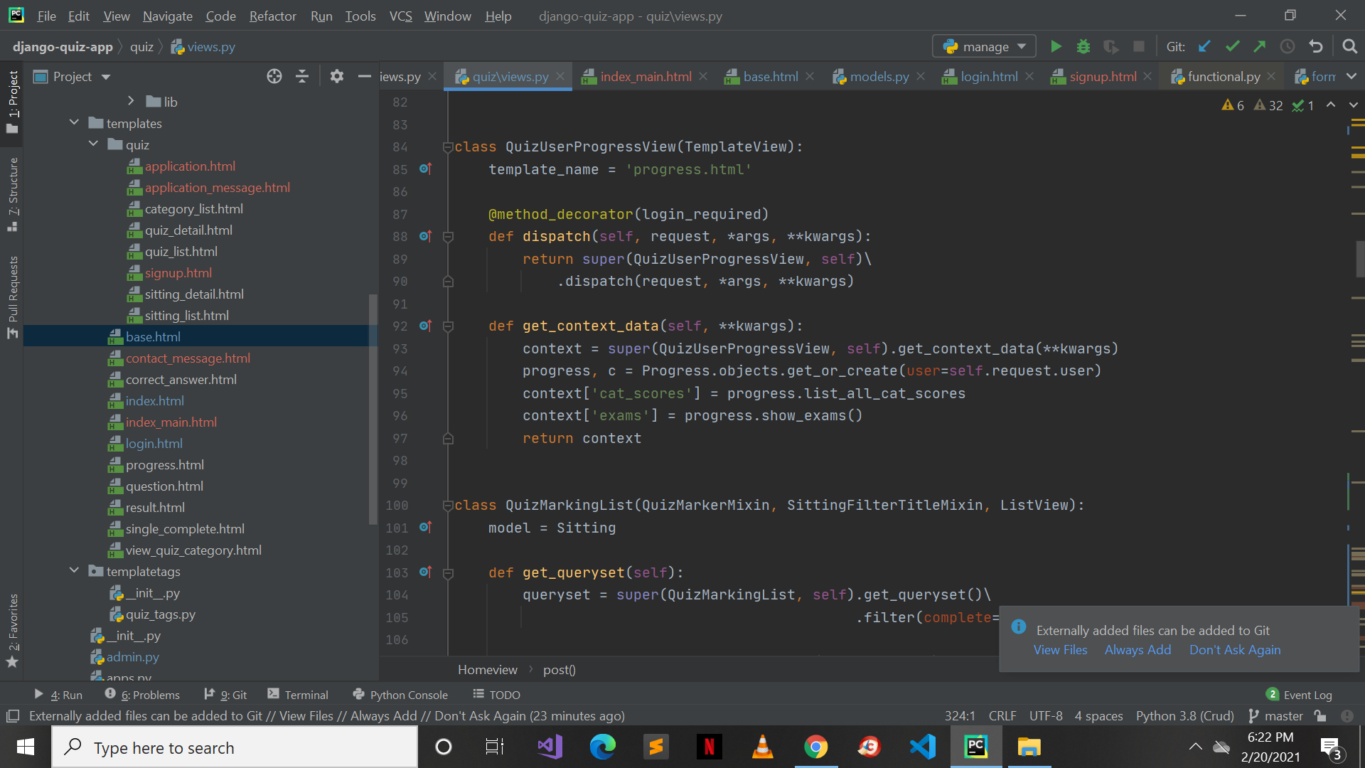

Figure-40: Student Result

**7.2.2 Decision Coverage Table**

### **Login Decision Table**

Table 29: Login Decision Table

|  |  |  |  |  |
| --- | --- | --- | --- | --- |
| **Conditions** | **Rule 1** | **Rule 2** | **Rule 3** | **Rule 4** |
| Email | F | F | T | T |
| Password | F | T | F | T |
| **Actions** |  |  |  |  |
| Wrong Credentials | T | T | T | F |
| User Logged in Successfully | F | F | F | T |

### **Attempt Quiz Decision Table**

Table 30: Attempt Quiz Decision Table

|  |  |  |  |  |  |  |  |  |
| --- | --- | --- | --- | --- | --- | --- | --- | --- |
| **Conditions** | **Rule 1** | **Rule 2** | **Rule 3** | **Rule 4** | **Rule 5** | **Rule 6** | **Rule 7** | **Rule 8** |
| Registered | F | F | F | F | T | T | T | T |
| Logged in | F | F | T | T | F | T | F | T |
| Quiz Created | F | T | F | T | T | F | F | T |
| **Actions** |  |  |  |  |  |  |  |  |
| Wrong Credentials | T | T | T | T | T | F | T | F |
| User Logged in Successfully | F | F | F | F | F | T | F | T |
| Quiz Visible/Shared | F | F | F | F | F | F | F | T |

**7.3 Traceability Matrix**

**7.3.1 RID vs UCID (Requirements vs Use Cases)**

Table 31: RID vs UCID

|  |  |  |  |  |  |  |  |  |  |  |  |  |  |  |  |  |  |  |  |  |
| --- | --- | --- | --- | --- | --- | --- | --- | --- | --- | --- | --- | --- | --- | --- | --- | --- | --- | --- | --- | --- |
|  | F R  1 | F R  2 | F R  3 | F R  4 | F R  5 | F R  6 | F R  7 | F R  8 | F R  9 | F R 10 | F R 11 | F  R 12 | F  R 13 | F  R 14 | N  F  1 | N  F  2 | N  F  3 | N  F  4 | N  F  5 | N  F  6 |
| **UC1** | **✔** | **✔** |  |  |  |  |  |  |  |  |  |  |  |  |  |  |  |  |  |  |
| **UC2** |  |  |  |  |  | **✔** |  |  | **✔** |  |  |  |  |  |  |  |  | **✔** |  |  |
| **UC3** |  | **✔** | **✔** |  | **✔** | **✔** |  |  |  |  |  | **✔** |  |  | **✔** |  | **✔** | **✔** | **✔** |  |
| **UC4** |  |  |  |  |  |  |  |  |  |  |  |  |  |  |  |  |  |  |  | **✔** |
| **UC5** |  |  |  |  | **✔** |  |  |  |  | **✔** |  |  |  | **✔** | **✔** | **✔** | **✔** |  |  |  |
| **UC6** |  | **✔** |  |  |  |  |  | **✔** |  |  | **✔** |  |  |  |  |  |  |  |  |  |
| **UC7** |  |  |  | **✔** |  |  |  |  |  |  |  | **✔** |  | **✔** |  |  |  |  |  |  |
| **UC8** |  |  |  |  |  |  |  |  |  |  |  |  |  |  |  |  |  |  |  |  |
| **UC9** |  |  |  | **✔** |  |  |  |  |  |  |  | **✔** |  |  |  | **✔** |  |  | **✔** | **✔** |
| **UC10** |  |  |  |  | **✔** |  |  | **✔** |  |  |  | **✔** |  |  |  |  |  |  |  |  |
| **UC11** |  | **✔** |  |  |  |  |  |  |  |  |  |  |  | **✔** | **✔** |  | **✔** |  |  |  |

**7.3.1 Prototypes RID vs PID**

Table 32: RID vs PID

|  |  |  |  |  |  |  |  |  |  |  |  |  |  |  |  |  |  |  |  |  |
| --- | --- | --- | --- | --- | --- | --- | --- | --- | --- | --- | --- | --- | --- | --- | --- | --- | --- | --- | --- | --- |
|  | F R  1 | F R  2 | F R  3 | F R  4 | F R  5 | F R  6 | F R  7 | F R  8 | F R  9 | F R 10 | F R 11 | F  R 12 | F  R 13 | F  R 14 | N  F  1 | N  F  2 | N  F  3 | N  F  4 | N  F  5 | N  F  6 |
| **P-1** |  |  |  |  | **✔** |  |  | **✔** |  |  |  |  | **✔** |  |  |  | **✔** | **✔** |  |  |
| **P-2** |  | **✔** |  |  |  |  |  |  |  |  | **✔** |  |  |  |  |  |  |  |  |  |
| **P-3** |  |  |  |  |  |  |  |  |  |  |  |  |  | **✔** |  |  |  |  |  | **✔** |
| **P-4** |  |  |  | **✔** | **✔** | **✔** |  |  | **✔** |  |  |  |  |  |  | **✔** |  |  |  |  |
| **P-5** |  |  |  |  |  |  |  |  |  | **✔** |  |  |  |  |  |  |  |  |  |  |
| **P-6** |  |  |  |  |  |  | **✔** |  |  |  |  | **✔** |  |  |  |  |  |  |  |  |
| **P-7** |  | **✔** |  |  |  |  |  |  |  |  |  |  |  |  |  |  | **✔** |  |  |  |
| **P-8** |  |  |  |  |  | **✔** |  |  |  |  |  |  |  |  |  |  |  |  |  |  |
| **P-9** |  |  | **✔** |  |  |  |  |  |  |  |  |  |  |  |  |  |  |  |  |  |
| **P-10** | **✔** |  |  |  |  |  |  |  |  |  | **✔** |  | **✔** |  |  |  |  |  | **✔** |  |

# **8.** Results/Output/Statistics

**8.1 %completion**

%Completion = (Fulfilled Requirements/Total Requirements) * 100

%Completion = (27/30) * 100

%Completion = (0.9) * 100

%Completion = 90%

**Project is 90% Complete**

**8.2 %accuracy**

%Accuracy = (Implemented Requirements/Total Requirements) * 100

%Accuracy = (24/27) * 100

%Accuracy = 88%

**Project is 100% Accurate**

**8.3 %correctness**

%Correctness = (Tested Requirements/Total Requirements) * 100

%Correctness = (25/27) * 100

%Correctness = (0.92) * 100

%Correctness = 92%

**Project is 92% Correct**

# **9.** Conclusion

QuizLobby, an online quiz taking website, will add to a contribution in this digitalizing era. Our team’s sole purpose is to ensure no hindrance in education especially in the times of the pandemic. With the introduction job work from home in 2020, we have also kept offices in mind; HR departments can conduct interview tests through our website. QuizLobby is also designed to be environmental friendly considering it requires no papers to be used. Once the website goes live, we will introduce more features to cover the needs of our users.

# **10.** Future Work

We plan on deploying this project after we graduate. Furthermore, our initial focus will be on adding more features in it so it can be as useful by our target market as possible. Our main focus will be on making it super user friendly and effective for our users. We will be introducing packages for our website as well. The users will be able to access some of the main features for free. However, they will have to purchase our packages to use additional features, making a source of income for us. InshaAllah.

# **11.** Bibliography

## **11.1 Books**

* Build Your First Website with Python and Django - By Nigel George
* Python Web Development with Django - By Jeff Forcier, Paul Bissex, Wesley J Chun

**11.2 Articles**

* Django documentation - <https://docs.djangoproject.com/en/3.1/>
* Python tutorial - <https://docs.python.org/3/tutorial/>
* https://medium.com/all-about-django/class-based-views-in-django-89108c1f51fb
* https://medium.com/@himanshuxd/how-to-create-registration-login-webapp-with-django-2-0-fd33dc7a6c67
* https://www.ordinarycoders.com/blog/article/using-django-form-fields-and-widgets
* https://simpleisbetterthancomplex.com/article/2017/08/19/how-to-render-django-form-manually.html
* <https://steelkiwi.com/blog/why-python-django-are-your-top-choice-for-web-development/>

**11.3 Research Papers**

* https://www.researchgate.net/publication/254006913_Web_development_with_python_and_django_abstract_only
* https://djangostars.com/blog/why-we-use-django-framework/
* http://www.ijfrcsce.org/download/conferences/Special_Issue/Special_Issue_Track/1578132412_04-01-2020.pdf

**12.** Appendix

## **12.1 Glossary of Terms**

* Teacher: A teacher is anyone who has the rights to create the quiz.
* Student: A student is anyone who has been assigned the quiz and has to solve it.
* Admin: Us, the creators.

**12.2 Pre-requisites**

* Python
* Django Framework
* Html
* CSS